ZAR LYNX × AINNA
Founder Financial
Command Centre
Finance Intelligence, Reconciliation & Management Reporting Layer
Proposed for
Zar Lynx Sdn Bhd
POC / Phase 1 Proposal
Prepared by AINNA | Powered by NeuralOps
Proposal date: 3 September 2026
Confidential — for discussion and scope validation.
Proposal Basis
This proposal is based on the current Zar Lynx finance survey submission. The survey is marked “Completed: No”; therefore, requirements should be validated during POC kickoff before final implementation scope is locked.

01 — EXECUTIVE SUMMARY
Extend SQL Accounting. Do not replace it.
Zar Lynx is not reporting a major finance-system failure. The stated objective is improvement: better financial visibility, faster month-end closing, cash-flow monitoring, management reporting, financial accuracy, audit readiness, cost control and better management decision-making.
AINNA proposes a Founder Financial Command Centre that sits above the existing finance environment. SQL Accounting remains the accounting system of record, while AINNA provides data ingestion, bank reconciliation, exception handling, management reporting and NeuralOps-powered financial intelligence.
Current requirement profile
Requirement | Survey response
Existing source systems | SQL Accounting + bank statements (PDF)
Scale | 1–5 users; approximately 500–2,000 transactions per month
Top priorities | Financial reporting, bank reconciliation, integration with existing systems, general ledger and budgeting
Reporting cadence | Weekly, monthly, quarterly and yearly
Expected outcome | Faster reporting, easier user experience, one central finance view and better financial accuracy
Recommended positioning
AINNA Finance Intelligence Layer
Position the POC as an intelligence and automation layer on top of the existing SQL Accounting workflow — not as a replacement accounting system.
SQL Accounting stays | Low-disruption POC | Founder visibility | AI-assisted analysis

02 — PROPOSED ARCHITECTURE
A controlled data-to-decision flow
Phase 1 starts with file-based ingestion to minimise implementation risk. Direct database or API integration can be evaluated after the POC proves the reconciliation logic, reporting model and management value.
01  Bank + SQL  Daily bank data  Weekly SQL export | 02  AINNA Import  Recompiler +  normalisation | 03  Reconcile  Matching, validation  & exceptions | 04  Finance Engine  P&L, BS, cash flow,  AR/AP, variance | 05  Command Centre  Admin operations +  Founder intelligence
Operating cycle
DAILY  Cash & movement  • Bank statement / transaction upload  • Cash position & bank movement  • Payment matching and exceptions  • Operational alerts | WEEKLY  Business performance  • SQL Accounting export  • Reconcile bank vs accounting data  • P&L, cash flow, AR/AP  • Founder weekly summary | MONTHLY  Management review  • Full reconciliation review  • Balance Sheet and P&L  • Budget vs actual  • Management observations
Data principle
System of record
SQL Accounting remains authoritative for accounting entries. AINNA should not silently rewrite accounting records. Exceptions, unmatched items and proposed classifications are surfaced for review and approval.

03 — PHASE 1 POC SCOPE
Prioritise the workflows with the highest management value.
01 | Bank Recompiler  Process supported bank-statement files into structured transaction data.
02 | SQL Accounting Import  Import agreed weekly exports from the existing accounting environment.
03 | Reconciliation Engine  Match banking and accounting records; identify unmatched and duplicate items.
04 | Finance Management View  Present P&L, Balance Sheet, cash flow, AR/AP and selected variance information based on validated data.
05 | Admin Operations View  Provide upload, reconciliation, exception and approval visibility for authorised finance users.
06 | Founder Command Centre  Provide simplified management KPIs, alerts, outstanding items and executive financial summaries.
07 | NeuralOps AI Layer  Support financial trend analysis, automatic analysis, budget variance analysis and an AI Finance Assistant against approved/validated data.
Controls requested by Zar Lynx
Maker / Checker | Payment Approval | Supporting Documents | Role-Based Access
Transaction Approval | Expense Approval | Audit Trail | Management Dashboard
Compliance note: The survey references MFRS, SST/GST records, LHDN e-Invoicing, CP204, annual tax returns and audited financial statements. These are important design constraints, but they should not be represented as fully automated POC deliverables unless explicitly scoped and validated.

04 — FOUNDER MOBILE EXPERIENCE
Founder Financial Command Centre
The Founder view should answer management questions quickly without requiring the user to navigate accounting ledgers. Zar Lynx requested full access, mobile access, email reports and a monthly summary, with visibility into revenue, outstanding supplier/customer payments, expenses, P&L, debt/loans, cash position and bank balance.
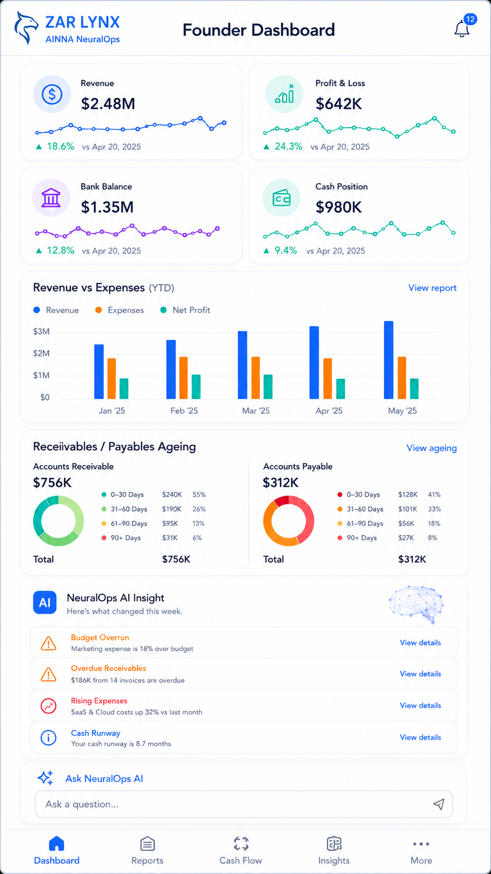
Illustrative mobile POC concept — dummy values shown for visual demonstration only.
Founder priority
Daily clarity on cash and outstanding commitments; weekly clarity on performance; monthly clarity on the overall financial position and management actions.

05 — ADMIN / FINANCE MOBILE EXPERIENCE
Operations, reconciliation and exceptions
The finance/admin view is operational rather than executive. It should make uploads, matching, reconciliation status, approvals and exceptions visible in one place, allowing the team to focus on transactions that require attention.
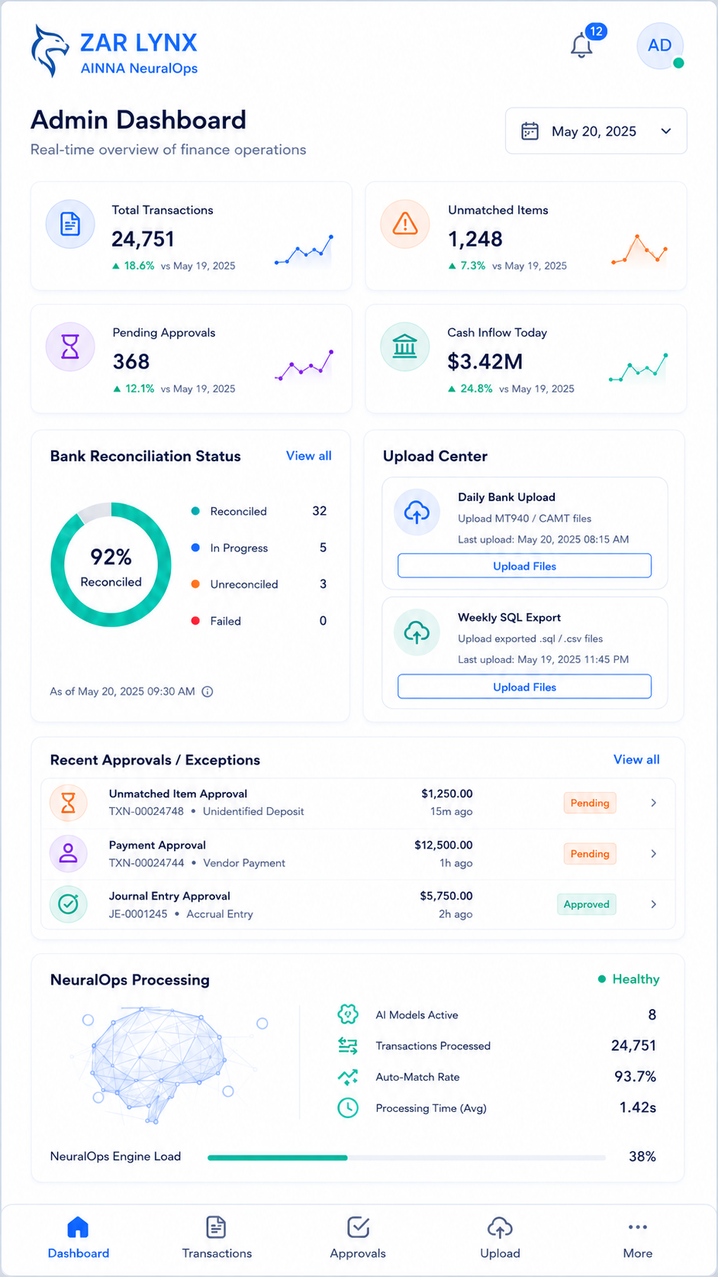
Illustrative mobile POC concept — dummy values shown for visual demonstration only.
Operational principle
Automate the repetitive checks; escalate the exceptions. Human review remains important for approvals, unmatched transactions and accounting judgement.

06 — NEURALOPS FINANCE INTELLIGENCE
AI should explain validated finance data — not invent it.
Zar Lynx selected four AI capabilities: AI Finance Assistant, Automatic Financial Analysis, Financial Trend Analysis and Budget Variance Analysis. The proposed NeuralOps layer should operate on approved or validated finance datasets and retain clear separation between source records, calculated outputs and AI-generated interpretation.
AI Finance Assistant  Natural-language questions over approved finance data, with answers tied to the available reporting scope. | Automatic Financial Analysis  Generate concise management observations and highlight material changes that warrant review.
Financial Trend Analysis  Compare revenue, expenses, collections, payments, cash position and other agreed indicators over time. | Budget Variance Analysis  Compare actual performance against budget and flag material deviations.
Guardrails for the POC
- SQL Accounting remains the accounting system of record.
- AI analysis is generated only after agreed validation/reconciliation steps.
- Low-confidence or unmatched items are shown as exceptions instead of being silently posted.
- Maker/Checker and role-based access should control sensitive actions.
- Audit trail should preserve who uploaded, reviewed, approved or changed a decision.
Example Founder questions
“What changed this week?” | “Which customers are overdue?”
“Where are we above budget?” | “What requires management attention now?”

07 — IMPLEMENTATION PATH
Validate first, automate deeper second.
PHASE 1 — POC | File-based workflow  Daily bank upload + weekly SQL export; reconciliation; admin/founder dashboards; selected AI analysis.
PHASE 2 — AUTOMATION | Scheduled integration  Evaluate automated ingestion, scheduled reports, alerts and deeper integration where technically supported.
PHASE 3 — SCALE | Expanded finance intelligence  Extend forecasting, approval workflows, multi-company/project views and additional management intelligence subject to validated requirements.
Expected outcomes
Faster reporting  Reduce the friction between source data and management-ready visibility. | Better financial visibility  Give Founder and management a single consolidated view of agreed KPIs.
More efficient reconciliation  Shift attention from line-by-line checking toward exceptions and unmatched items. | Better management decisions  Use validated financial data plus concise NeuralOps analysis to highlight material changes.
Improved control  Support maker/checker, approvals, role-based access, supporting documents and auditability. | Lower implementation disruption  Retain SQL Accounting while proving value through a controlled overlay POC.
Scope confirmation before build
Before implementation, AINNA and Zar Lynx should confirm the exact SQL export format, supported bank-statement formats, required reporting dimensions, approval thresholds, user roles, historical data period, budget source and the boundary between POC reporting versus statutory/tax compliance functions.
Recommended next step
Conduct a short data-and-process validation session using one representative SQL Accounting export and one representative bank statement. From that session, lock the POC data mapping, reconciliation rules, dashboard KPIs and acceptance criteria.
Commercial terms, implementation timeline and final deliverables can be issued after scope validation.

