 |  | Journal of Advanced Research in Business and Management Studies |  | 
Journal homepage:
https://karyailham.com.my/index.php/arbms/index
ISSN: 2462-1935
Digital Transformation Capability as a Driver of Agropreneurial Performance in Social Commerce Context
Abd Razzif Abd Razak^{1*}, Nur Hafizah Roslan^{2,}, Siti Faizah Zainal³, Siti Nurulaini Azmi⁴, Nur Syairah Ani⁵, Nurul Illahi Zainal Abidin⁶ , Mohd Shahir Omar⁷

Given Name | Family Name | Email
1. Abd Razzif | 1. Abd Razak | 1. razzif@fpe.upsi.edu.my
2. Nur Hafizah | 2. Roslan | 2. nurhafizahroslan@fpe.upsi.edu.my
3. Siti Faizah | 3. Zainal | 3. faizahz@fpe.upsi.edu.my
4. Siti Nurulaini | 4. Azmi | 4. aini.azmi@fpe.upsi.edu.my
5. Nur Syairah | 5. Ani | 5. nursyairah@fpe.upsi.edu.my
6. Nurul Illahi | 6. Zainal Abidin | 6. nurulillahi@uitm.edu.my
7. Mohd Shahir | 7. Omar | 7. shahiromar@fama.gov.my

¹ | Department of Business Management and Entrepreneurship, Faculty of Management and Economics, Universiti Pendidikan Sultan Idris Malaysia, 35900 Tanjong Malim, Perak, Malaysia
² | Department of Accounting and Finance, Faculty of Management and Economics, Universiti Pendidikan Sultan Idris Malaysia, 35900 Tanjong Malim, Perak, Malaysia
³ | International Business and Management Division, Faculty of Business Management, Universiti Teknologi MARA, 42300 Bandar Puncak Alam, Selangor, Malaysia
⁴ | Federal Agricultural Marketing Authority, 68100 Batu Caves, Selangor, Malaysia

ARTICLE INFO |  |  | ABSTRACT
Article history:  Received  Received in revised form  Accepted  Available online |  |  | The rapid expansion of social commerce has transformed entrepreneurial activity by enabling small firms to reach broader markets through integrated content, interaction and transaction functions. Yet platform access alone does not explain why some agropreneurs convert digital activity into stronger business performance. This study examines the relationships between adaptive content capability, platform capability utilisation, institutional alignment capability and agropreneurial performance in the Agromarketing Masterclass TikTok Shop Edition (AMTTSE), a government-supported digital entrepreneurship programme implemented by the Federal Agricultural Marketing Authority (FAMA), Malaysia. A quantitative, non-experimental and cross-sectional design was applied to programme data associated with 80 companies, 160 entrepreneurs, 425 stock-keeping units and 13 companies owned by persons with disabilities during June-December 2024. Partial least squares structural equation modelling assessed the reported capability relationships, and the indirect effect was evaluated through 5,000 bootstrap resamples. The available record indicates significant positive relationships for the three capability paths and a significant mediating relationship through platform capability utilisation. Because the available archival record did not preserve the original structural-model output, effect magnitudes, path coefficients, t-values, p-values, confidence intervals and explained variance cannot be reported in this revised manuscript. Programme records reported cumulative gross merchandise value of RM6,205,957.06 and a return ratio of 1:31. The findings suggest that agropreneurial performance is associated with a configuration of content, platform and institutional capabilities, while the non-experimental design precludes causal interpretation.
Keywords:
Agromarketing Masterclass TikTok Shop Edition; digital transformation capability; agropreneurial performance; social commerce; resource-based view; dynamic capabilities theory; institutional theory
1. Introduction
Digital transformation and the changing entrepreneurial environment
Digital transformation has moved from a technology-adoption concern to a strategic question about how organisations reconfigure value creation, operating routines and stakeholder relationships. The digital economy now connects data, platforms, mobile interfaces and transaction infrastructures in ways that alter how opportunities are recognised and exploited. For micro, small and medium-sized enterprises (MSMEs), this shift can lower some market-entry barriers while simultaneously creating new capability demands. Digital visibility is easier to obtain, but sustained commercial conversion requires entrepreneurs to combine market knowledge, content production, platform execution and operational discipline. Digital transformation is therefore not synonymous with opening an online account. It is an organisational change process in which digital technologies reshape the means through which value is proposed, delivered and captured [1-5].
Industry 4.0 initially foregrounded cyber-physical systems, automation, connectivity and data-intensive production. Its strategic relevance has subsequently extended beyond manufacturing because interconnected technologies also influence retailing, services and agricultural value chains [6,7]. Society 5.0 adds a human-centred emphasis by positioning digital systems as instruments for addressing social and economic needs rather than as ends in themselves [8]. These perspectives are relevant to agropreneurship because digital transformation must produce accessible and commercially meaningful outcomes for enterprises that vary widely in size, location, resources and prior experience. Technology-centred programmes risk measuring access while overlooking whether entrepreneurs can use that access to generate market participation.
The Malaysian policy environment reflects this broader transition. The Malaysia Digital Economy Blueprint, National Fourth Industrial Revolution Policy, Twelfth Malaysia Plan and New Industrial Master Plan 2030 each emphasise digitally enabled productivity, innovation and enterprise development [9-12]. The National Agrofood Policy 2021-2030 similarly positions modernisation, market access and resilient value chains as central to sectoral development [13]. These policy ambitions place digital competitiveness within a coordinated national agenda. Their success, however, depends on implementation at firm level, where small enterprises must translate infrastructure, training and institutional support into repeatable commercial routines.
Social commerce, TikTok Shop and the platform economy
Social commerce combines social interaction, content discovery and transaction capability within a digitally mediated environment. Unlike conventional e-commerce, where consumers often begin with a deliberate product search, social-commerce discovery may emerge through entertainment, creator communication, peer interaction or real-time demonstrations. Trust, social support and relationship quality consequently become intertwined with platform affordances [14,15]. Livestream commerce reduces some information uncertainty by allowing sellers to demonstrate products, answer questions and respond to customers in real time [16-20]. Short-form video adds persistent and scalable discovery, enabling a product narrative to circulate beyond the temporal boundaries of a live session.
TikTok Shop exemplifies the convergence of content and commerce. Sellers operate within a platform ecosystem whose recommendation systems, interfaces, promotional tools and transaction rules influence visibility and conversion. The entrepreneur does not control this infrastructure but can develop routines for using it. Platform ecosystems therefore distribute agency across platform owners, complementors, creators, sellers and users [21-25]. This interdependence is strategically important: access to an audience is accompanied by dependence on platform governance, changing formats and commercial rules. Effective participation requires more than technical familiarity; it requires the ability to connect content, product listings, interaction, ordering and fulfilment into a coherent pathway.
Research on livestream commerce has predominantly examined consumers' purchase intentions, trust, parasocial interaction and engagement [16-20,26-30]. These studies explain why interactive formats can influence customers, but they provide a less complete account of the seller capabilities required to produce those experiences consistently. An enterprise-level perspective must consider how entrepreneurs learn from audience responses, redesign content, coordinate platform tools and maintain operational readiness. The relevant question is not merely whether livestreaming or short video works, but why some firms can mobilise these formats more effectively than others.
Agricultural digitalisation and Malaysian agropreneurship
Agricultural digitalisation is frequently discussed in relation to precision farming, advisory services, production data and supply-chain coordination. Recent research nevertheless shows that adoption is shaped by infrastructure, skills, institutional arrangements and the lived realities of smaller producers [31-38]. Downstream market digitalisation presents a related but distinct challenge. Agro-based enterprises must communicate provenance, preparation, quality, certification and product use while managing constraints such as perishability, inventory variability, logistics and food-safety expectations. Digital tools may extend reach, but commercial performance depends on whether these constraints are incorporated into the selling process.
Malaysian agropreneurs operate at the intersection of enterprise development and public agricultural policy. Government agencies provide training, market facilitation and institutional legitimacy, while platforms supply audience access and transaction infrastructure. This configuration creates an entrepreneurship ecosystem rather than a simple bilateral relationship between a seller and customer. Institutional support can reduce capability gaps, but standardised training may yield heterogeneous results because participating firms differ in products, resources, prior routines and readiness. Inclusive programme design must therefore distinguish attendance from capability formation and capability formation from realised performance.
The AMTTSE was introduced by FAMA as a structured intervention in practical digital marketing, content creation and social-commerce execution. Programme records cover 80 companies, 160 entrepreneurs, 425 stock-keeping units and 13 companies owned by persons with disabilities. Cumulative gross merchandise value during June-December 2024 was RM6,205,957.06, with a programme-reported return ratio of 1:31. These figures demonstrate substantial commercial activity, but gross merchandise value is not profit and the return ratio remains dependent on its documented cost base. More importantly, aggregate outcomes do not explain the capability mechanisms associated with entrepreneurial performance.
Digital transformation capability
Digital transformation capability describes an organisation's capacity to purposefully mobilise digital technologies, knowledge and routines in support of strategic and operational change. It differs from digital adoption because ownership or access does not establish competent use. Reviews of digital transformation consistently emphasise organisational reconfiguration, strategic renewal and the integration of technological and human resources [1-5,39]. For SMEs, capability development is constrained by limited slack resources, owner-manager dependence and uneven access to specialised expertise, yet their smaller structures may also permit rapid experimentation [40-47].
In the present study, digital transformation capability is represented through adaptive content capability, platform capability utilisation and institutional alignment capability. Adaptive content capability concerns the ability to adjust market-facing communication according to product attributes, audience feedback and platform conditions. Platform capability utilisation concerns the coordinated use of available platform functions to connect visibility, interaction and transaction. Institutional alignment capability concerns the ability to organise entrepreneurial activity in relation to programme support, public-agency expectations and the wider institutional environment. These dimensions are analytically distinct while remaining mutually reinforcing in practice.
Measurement of digital capability commonly relies on multi-item assessments of skills, routines, integration and strategic use, sometimes complemented by objective digital traces. The present manuscript retains the original construct structure and reported means, but does not reconstruct item wording or psychometric statistics that were absent from the available record. This reporting boundary is important because measurement quality cannot be inferred from programme scale or commercial outcomes. A complete archival package should preserve the questionnaire, coding decisions, measurement-model output and the unit used in structural analysis.
Theoretical integration and expected relationships
The Resource-Based View (RBV), Dynamic Capabilities Theory (DCT) and Institutional Theory address different but interdependent parts of the explanation developed in this study. RBV begins inside the firm and asks why enterprises facing a broadly similar market environment achieve heterogeneous outcomes. Its answer lies in differences in the resources and capabilities that firms control and organise [49]. For agropreneurs, product knowledge, customer insight, brand credibility, content-production routines and fulfilment know-how can become strategically valuable when combined in ways that support market exchange. Access to TikTok Shop is not, by itself, a rare resource because the technical infrastructure is available to many sellers. Heterogeneity instead arises from the firm-specific routines through which entrepreneurs connect product attributes, audience understanding and operational execution. RBV therefore establishes the resource foundation of the model: digital tools create potential, but organised capability determines whether that potential becomes commercially useful.
RBV alone is insufficient in a social-commerce setting because it can appear comparatively static. A valuable resource bundle at one point may lose relevance when platform formats, recommendation mechanisms, customer preferences or campaign rules change. DCT supplies the temporal and process logic that RBV lacks by explaining how firms sense changes, seize opportunities and reconfigure their resource base [50-53]. Adaptive content capability reflects sensing because entrepreneurs interpret audience reactions, product questions and changing content conventions. It also entails reconfiguration when those signals are translated into revised narratives, demonstrations or livestream practices. Platform capability utilisation reflects seizing and orchestration because visibility must be linked to listings, interaction, ordering and fulfilment. DCT thus explains how an inherited stock of knowledge and routines is repeatedly renewed rather than simply possessed.
The relationship between RBV and DCT is complementary rather than substitutive. RBV identifies what may underpin performance heterogeneity, whereas DCT explains how the usefulness of those resources is maintained under change. Content expertise without adaptation may become obsolete; adaptation without a substantive resource base may produce activity without a coherent value proposition. In the present framework, adaptive content capability and platform capability utilisation are therefore not isolated variables appended to separate theories. They represent connected stages through which resource endowments are interpreted, modified and deployed. This synthesis also clarifies why platform access cannot be equated with digital transformation. Transformation occurs when entrepreneurs convert generic technological affordances into situated routines that reflect their products, customers and operating constraints.
Institutional Theory extends the explanation beyond managerial discretion. Agropreneurs do not deploy capabilities in an institutional vacuum. Formal platform rules, programme requirements, public-agency procedures, food and product standards, and data-reporting expectations establish permissible and legitimate modes of action. Normative expectations concerning professional selling and trusted agricultural products also influence behaviour, while shared assumptions about appropriate digital practice shape what entrepreneurs and programme administrators regard as effective [54,55]. AMTTSE adds a particularly salient institutional layer because FAMA supplies programme legitimacy, training and market facilitation while TikTok Shop controls important elements of the transaction infrastructure. Institutional alignment capability captures the entrepreneur's capacity to interpret, access and incorporate these arrangements into business routines rather than treating alignment as passive compliance.
Institutional conditions can enable capability deployment by reducing information gaps, legitimising unfamiliar selling practices, connecting firms with training and creating structured opportunities for experimentation. The same conditions may constrain deployment when standardised programme schedules do not fit product cycles, when platform rules change, or when reporting requirements consume scarce managerial attention. Institutional support should therefore not be modelled as an automatically beneficial input. Its value depends on the entrepreneur's capacity to absorb and translate support, and on the fit between institutional arrangements and firm-level needs. This boundary condition is important for interpreting the institutional-alignment relationship: a positive association is consistent with useful support and effective engagement, but it does not show that every institutional requirement improves performance or that the programme alone generated commercial outcomes.
Potential tensions among the three theories arise from their assumptions about agency, advantage and conformity. RBV emphasises firm heterogeneity and the protection of distinctive resources, whereas institutional accounts explain why organisations exposed to common pressures may become more alike. DCT stresses entrepreneurial agency and purposeful reconfiguration, while Institutional Theory recognises that rules, norms and dependence can limit the feasible choices available to firms. These tensions are analytically useful. Programme standardisation may create a common capability floor but can also narrow experimentation. Compliance may secure legitimacy and resources while diverting effort from firm-specific differentiation. Conversely, distinctive content that departs too far from platform or regulatory expectations may be commercially creative but institutionally untenable. Performance consequently depends on balancing differentiation, adaptation and legitimacy rather than maximising any one in isolation.
The theories also operate at different levels. RBV and DCT principally explain intra-firm resources and managerial processes, while Institutional Theory addresses the organisational field in which those processes occur. The levels connect through institutional alignment capability. External support or constraint does not affect all firms uniformly; it is filtered through entrepreneurs' prior resources and adaptive capacity. Likewise, internally developed capability does not produce the same return under every institutional configuration. Platform governance, agency support, regional infrastructure and product regulation may strengthen or weaken the translation of capability into performance. Institutional context therefore serves both as a source of resources and as a boundary condition on the RBV-DCT mechanism.
This integrated logic yields the sequence shown in Figure 1. RBV explains the strategic resource base; DCT explains its continuing reconfiguration; Institutional Theory specifies the enabling and constraining context; and together they explain the formation and deployment of digital transformation capability. Within the empirical model, adaptive content capability captures market-facing adaptation, platform capability utilisation captures the conversion interface, and institutional alignment capability captures engagement with the support and governance environment. Agropreneurial performance is associated with how these elements operate as a configuration, not with technology possession alone.
All three theories are therefore required simultaneously. An RBV-only account would understate change and external dependence. A DCT-only account would explain adaptation without fully specifying the resource base or institutional limits within which adaptation occurs. An institutional-only account would explain support, legitimacy and constraint but would not account adequately for persistent differences among firms participating in the same programme. Their synthesis supports the study's hypotheses while preserving clear theoretical boundaries: H1 links adaptive content capability with performance through valuable and renewable routines; H2 links platform capability utilisation with performance through opportunity seizure and resource orchestration; H3 links institutional alignment capability with performance through access, legitimacy and fit; and H4 positions platform utilisation as the mechanism through which adaptive content becomes commercially actionable. These remain hypothesised and observed associations rather than deterministic or causal claims.
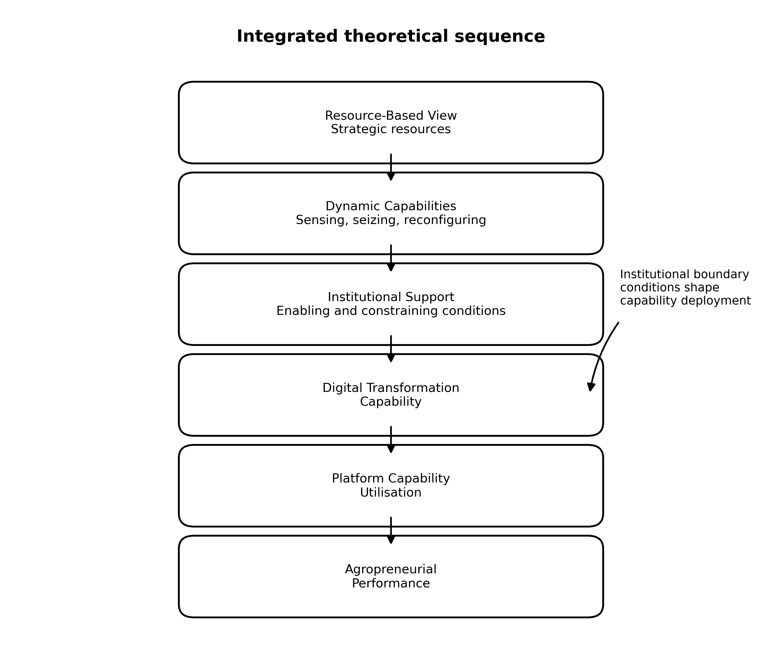
Figure 1. Integrated Theoretical Framework
Note: The sequence synthesises RBV, DCT and Institutional Theory as complementary explanations operating across firm and institutional levels.
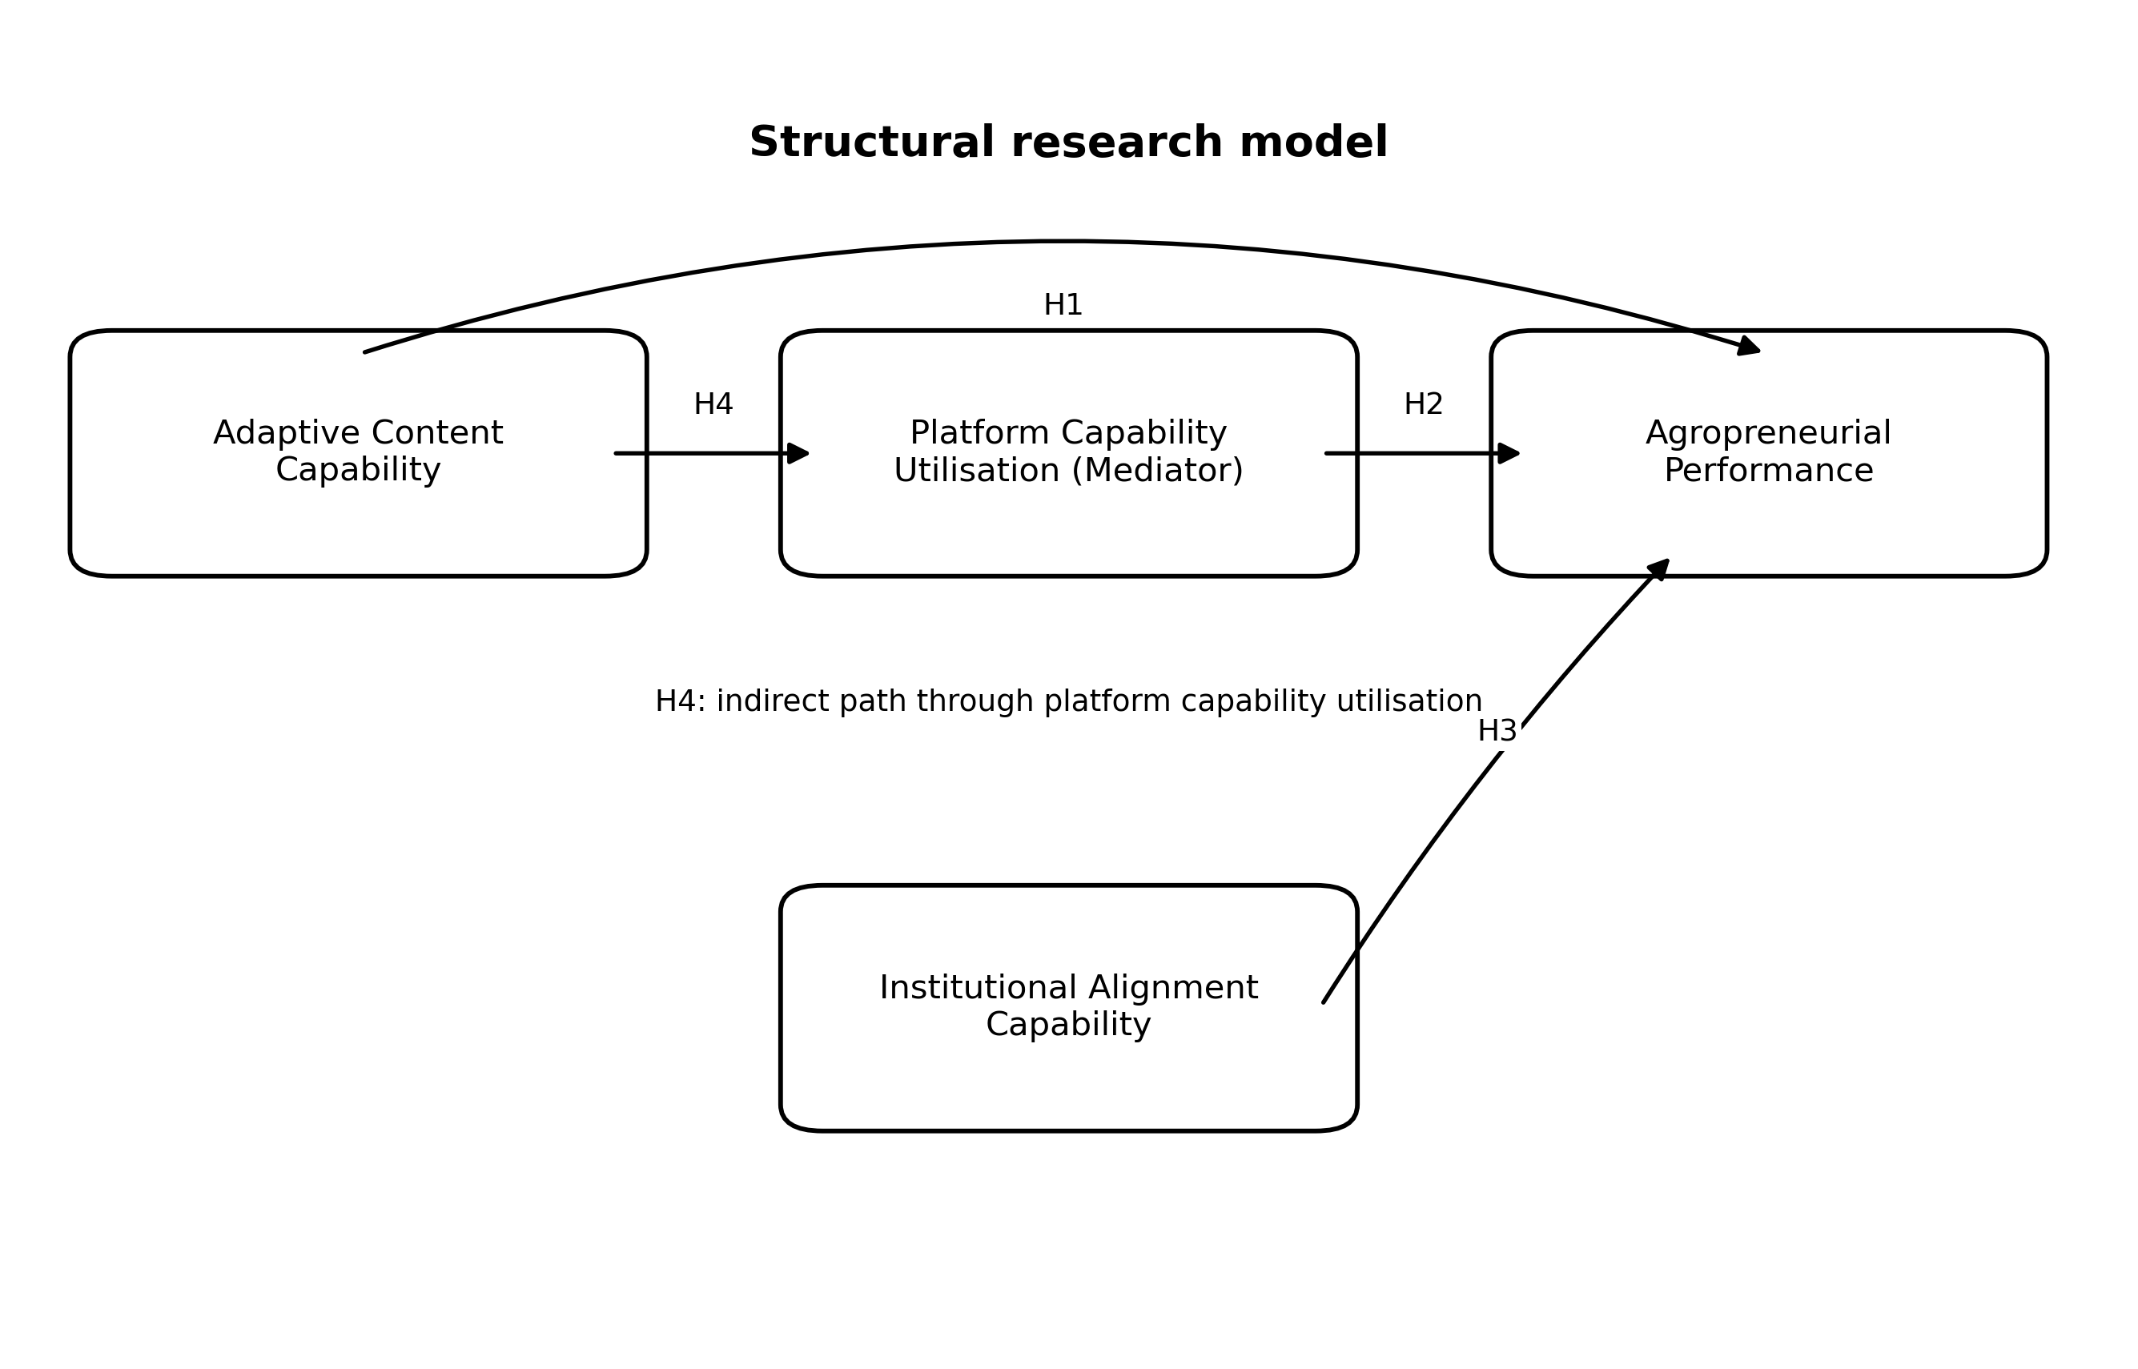
Figure 2. Structural Research Model
Note: H4 denotes the indirect relationship from adaptive content capability to performance through platform capability utilisation.
Research gap and study objective
Five gaps motivate the study. The theoretical gap concerns limited integration of RBV, Dynamic Capabilities Theory and Institutional Theory in explaining content-led entrepreneurship. The empirical gap concerns the scarcity of evidence linking seller capabilities with recorded programme performance. The contextual gap concerns agropreneurs operating in an emerging-economy social-commerce programme. The methodological gap concerns the separation between aggregate programme metrics and latent capability relationships. The policy gap concerns the tendency to evaluate digital programmes through participation counts and headline sales without specifying how capabilities are converted into performance.
Accordingly, the study investigates the influence of digital transformation capability on agropreneurial performance within AMTTSE, focusing on adaptive content capability, platform capability utilisation, institutional alignment capability and the mediating role of platform capability. The research objective, research questions, hypotheses and conceptual framework are retained from the original manuscript. The contribution lies in deepening their theoretical rationale and interpreting the reported findings without changing the dataset, research design or statistical results.
2. Methodology
2.1 Research Design
The study employed a quantitative, non-experimental and cross-sectional design to examine relationships among digital transformation capabilities, institutional factors and agropreneurial performance. A post-positivist orientation is consistent with this design because the study estimates patterned relationships using observable indicators while recognising that measurement and model specification are imperfect representations of underlying constructs. The design is descriptive and correlational rather than experimental. It therefore supports association and prediction within the specified model but does not establish that the capabilities caused subsequent performance.
AMTTSE provides a bounded empirical setting in which agropreneurs engaged with a common training and platform environment. Administrative performance records span June-December 2024, whereas the latent-capability analysis is reported as cross-sectional. The period-based records must not be described as a longitudinal structural design unless capability measures were repeatedly collected. Seasonal purchasing, promotional campaigns, seller entry and prior experience remain plausible alternative explanations for changes in aggregate sales.
2.2 Data Collection
The programme dataset contains information associated with 80 participating companies, 160 entrepreneurs, 425 stock-keeping units, content activity, product movement, orders, sales channels and seller-level gross merchandise value. Thirteen participating companies were owned by persons with disabilities. The accessible population was defined by enrolment in AMTTSE, and the administrative records covered the June-December 2024 monitoring period. The geographic distribution is reported in Table 1.
The analytical record combines programme-level administrative indicators with construct-level capability measures. The distinction is essential: company counts, products, orders and GMV are administrative observations, while adaptive content capability, platform capability utilisation, institutional alignment capability and agropreneurial performance are latent constructs used in the structural model. The original measurement development, instrument wording, scale anchors, administration mode and respondent-to-company linkage were not available in the reporting file used for this expansion. They have therefore not been reconstructed or invented. These items should be recovered from the approved instrument before final submission if the journal requests full measurement documentation.
The original manuscript reports 80 companies and 160 entrepreneurs but does not specify whether the PLS-SEM analytical unit was the company, entrepreneur or another linked observation. The programme scope is retained exactly, while no unsupported structural-model sample size is introduced. A final technical appendix should state how entrepreneurs associated with the same company were handled, because clustering affects independence and effective sample size.
2.3 Analytical Procedures
Structural equation modelling with partial least squares (PLS-SEM) was used to evaluate the conceptual model. PLS-SEM is appropriate where the objective includes explaining variance and assessing a model with multiple latent relationships, subject to correct measurement specification and adequate sample reporting [56,57]. The indirect relationship was evaluated using non-parametric bootstrapping with 5,000 resamples, avoiding reliance on a normal sampling distribution for the mediated effect [58].
A complete PLS-SEM assessment ordinarily separates the measurement model from the structural model. For reflective constructs, internal consistency, indicator reliability, convergent validity and discriminant validity should be reported. Composite reliability and rho_A complement Cronbach's alpha, average variance extracted assesses convergent validity, and the heterotrait-monotrait ratio provides a stringent discriminant-validity criterion [59]. For formative constructs, indicator collinearity and the relevance and significance of weights are central. The present paper retains the original statement that reliability and validity checks were conducted but does not fabricate loadings, reliability coefficients, AVE or HTMT values absent from the source record.
Structural-model reporting should include collinearity diagnostics, path coefficients, bootstrap confidence intervals, explained variance, effect sizes and predictive assessment where available [56,60]. The surviving record establishes the direction and significance of the stated relationships but does not contain numerical path coefficients or confidence intervals. Results are therefore interpreted directionally, and no relationship is ranked by magnitude. The mediation finding is similarly restricted to the reported significant indirect relationship; its size, type and proportion mediated cannot be determined without the original output.
Data screening should document duplicate handling, missing values, implausible ranges, outliers and the reconciliation of channel totals with cumulative GMV. PLS-SEM does not require multivariate normality, but distributional inspection remains relevant for understanding data quality and selecting inferential procedures. Common method bias should also be assessed where predictors and outcomes derive from the same respondent and collection occasion. Procedural remedies, collinearity-based diagnostics or marker-variable approaches should only be reported if they were actually implemented.
The study used programme records in an institutional setting. Ethical reporting must distinguish administrative data governance from human-participant research. The original ethics, consent and data-access statements are retained at the end of the paper, but no approval identifier or undocumented procedure is introduced. Seller names appear only in the existing source appendix. Any public release of participant-level data remains subject to institutional authorisation and applicable privacy requirements.
3. Results
3.1 Descriptive Statistics
Descriptive statistics indicated moderate to high reported capability levels. Platform capability utilisation averaged 3.7, while institutional alignment capability averaged 3.9. Interpretation of these means depends on the original response scale and dispersion statistics, which were not contained in the reporting file. The values are therefore retained without assuming scale anchors or homogeneity among respondents. Performance outcomes showed substantial variation across entrepreneurs, a pattern consistent with the seller-level heterogeneity reported in the appendices.
Table 1
Distribution of Participating Companies by State
No. | State | Companies (n) | Share (%)
1 | Perlis | 1 | 1.3
2 | Kedah | 3 | 3.8
3 | Penang | 2 | 2.5
4 | Perak | 8 | 10.0
5 | Kuala Lumpur | 6 | 7.5
6 | Selangor | 33 | 41.3
7 | Negeri Sembilan | 5 | 6.3
8 | Melaka | 1 | 1.3
9 | Johor | 4 | 5.0
10 | Pahang | 3 | 3.8
11 | Kelantan | 8 | 10.0
12 | Terengganu | 4 | 5.0
13 | Sabah | 1 | 1.3
14 | Sarawak | 1 | 1.3
 | Total | 80 | 100.0
Source: FAMA TikTok Shop Performance Report (2024).
Table 1 shows that participation was geographically uneven. Selangor accounted for 33 of the 80 companies (41.3%), while several states were represented by a single enterprise. This distribution establishes national reach but not geographically balanced representation. Market proximity, logistics, connectivity and access to complementary support may differ across locations; consequently, the results should not be generalised as state-comparative evidence.
Table 2
Summary of AMTTSE Performance
Indicator | Value
Number of Companies | 80
Number of Participants | 160
Total SKUs Marketed | 425
PWD-Owned Companies | 13
Cumulative Sales (Jun-Dec 2024) | RM6,205,957.06
Return on Investment | 1:31
Source: FAMA TikTok Shop Performance Report (2024).
Table 2 demonstrates programme reach across companies, entrepreneurs and product offerings. The inclusion of 13 PWD-owned companies is relevant to inclusive entrepreneurship, although the table does not establish subgroup performance. Cumulative GMV records transaction value rather than profit or evenly distributed participant income. Similarly, the reported 1:31 ratio should be interpreted according to the programme's cost definition and not as RM31 of net profit for every ringgit invested.
Table 3
Sales Value by Sales Channel
Sales Channel | Sales Value (RM) | Share (%)
Livestream | 2,105,670.00 | 33.9
Window (Profile Sales) | 1,875,034.00 | 30.1
Short Video | 1,621,255.00 | 26.1
Others (Shop Tab) | 603,998.06 | 9.9
Total | 6,205,957.06 | 100.0
Source: FAMA TikTok Shop Performance Report (2024).
Table 3 is retained exactly from the original manuscript. Its channel allocation differs from Appendix Table A3 even though both report the same cumulative total. This unresolved source inconsistency prevents ranking the channels from Table 3 as definitive. The discrepancy should be reconciled against the primary FAMA export before journal submission; no value has been silently replaced in this revision.
3.2 Hypothesis Testing Results
The hypothesis testing results demonstrated significant positive relationships across all hypotheses. Adaptive content capability, platform capability utilisation and institutional alignment capability were significantly related to agropreneurial performance. Platform capability utilisation also significantly mediated the relationship between adaptive content capability and performance outcomes. Because numerical coefficients and confidence intervals were unavailable, the interpretation that follows explains theoretical meaning and practical significance without asserting effect magnitude.
The significant adaptive-content relationship supports the view that content is a strategic routine rather than a simple promotional output. In social commerce, agropreneurs must explain product attributes, demonstrate use, establish credibility and respond to audience interests. Adaptation allows entrepreneurs to refine these activities as feedback and platform conditions change. This interpretation is consistent with the RBV because the strategically valuable resource is not access to recording tools but the firm-specific combination of product knowledge, audience understanding and execution [48]. It is also consistent with dynamic-capability reasoning because valuable routines must be renewed rather than repeated mechanically [50-52].
The finding aligns with research showing that digital strategy and capabilities can support SME performance, agility and business-model innovation [41-47]. Its social-commerce context extends this literature by locating capability in a content-to-transaction environment. However, reverse association and omitted variables remain possible. Better-performing firms may possess more resources for content creation, while product attractiveness, pricing, reputation and fulfilment can influence both perceived capability and outcomes. The cross-sectional result is therefore theoretically consistent but not causal.
Platform capability utilisation was also significantly related to agropreneurial performance. The result indicates that platform participation is not binary: sellers differ in how effectively they coordinate discovery, product information, customer interaction, ordering and fulfilment. Platform research emphasises that entrepreneurs operate within infrastructures controlled by platform owners [21-25]. The entrepreneur obtains market access but must configure generic platform resources around a viable product and customer proposition. Training should consequently address the complete conversion pathway rather than treating account creation, posting or livestream duration as sufficient performance indicators.
Institutional alignment capability was significantly related to performance, supporting the argument that entrepreneurial action remains embedded in organisational fields. FAMA's programme support, platform requirements and agricultural-market obligations form part of the environment in which entrepreneurs act. Alignment can help firms interpret expectations, access resources and coordinate programme participation with operational routines. This finding is compatible with Institutional Theory [53,54] and with evidence that institutional configurations influence entrepreneurial activity [55]. It does not demonstrate that government intervention alone generated the recorded GMV; stronger firms may be simultaneously better able to engage institutions and markets.
The significant mediation result provides a more specific mechanism. Adaptive content capability can create relevant market communication, but commercial value is realised only when attention is connected to platform-supported interaction and transaction. Platform utilisation plausibly transmits part of the content-performance relationship by operationalising discovery, product access and purchase. This logic is consistent with research on social-commerce affordances, trust and engagement [14-20]. Nevertheless, the result establishes a significant reported indirect relationship rather than a chronological causal sequence. Without the indirect coefficient, bootstrap interval and corresponding direct effect, the mediation cannot be classified or quantified.
The programme-level evidence complements but does not test the latent structural model. Monthly GMV rose from RM497,762.95 in June to RM1,705,942.05 in December. This trajectory may be compatible with accumulated execution capability, but seasonality, campaigns, seller activation and product availability are plausible alternatives. Appendix Table A5 also contains correlations between channel components and total monthly sales. Because these variables share arithmetic components and are based on seven monthly observations, the high coefficients are exploratory and should not be presented as independent confirmation of the PLS-SEM relationships.
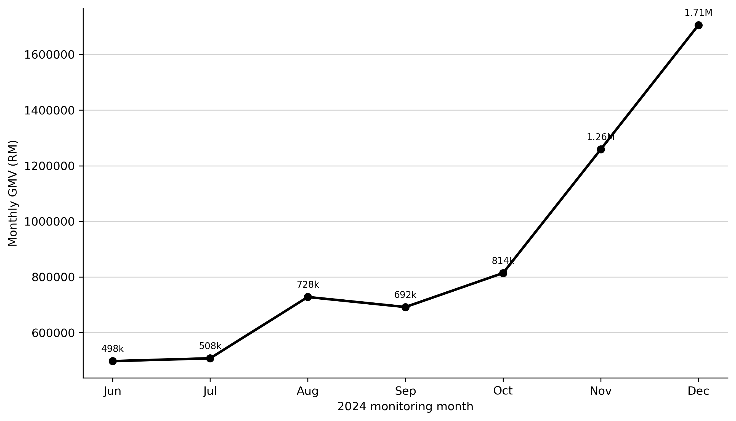
Figure 3. Monthly Programme Performance
Source: Appendix Table A2. The descriptive trajectory does not establish programme or capability causality.
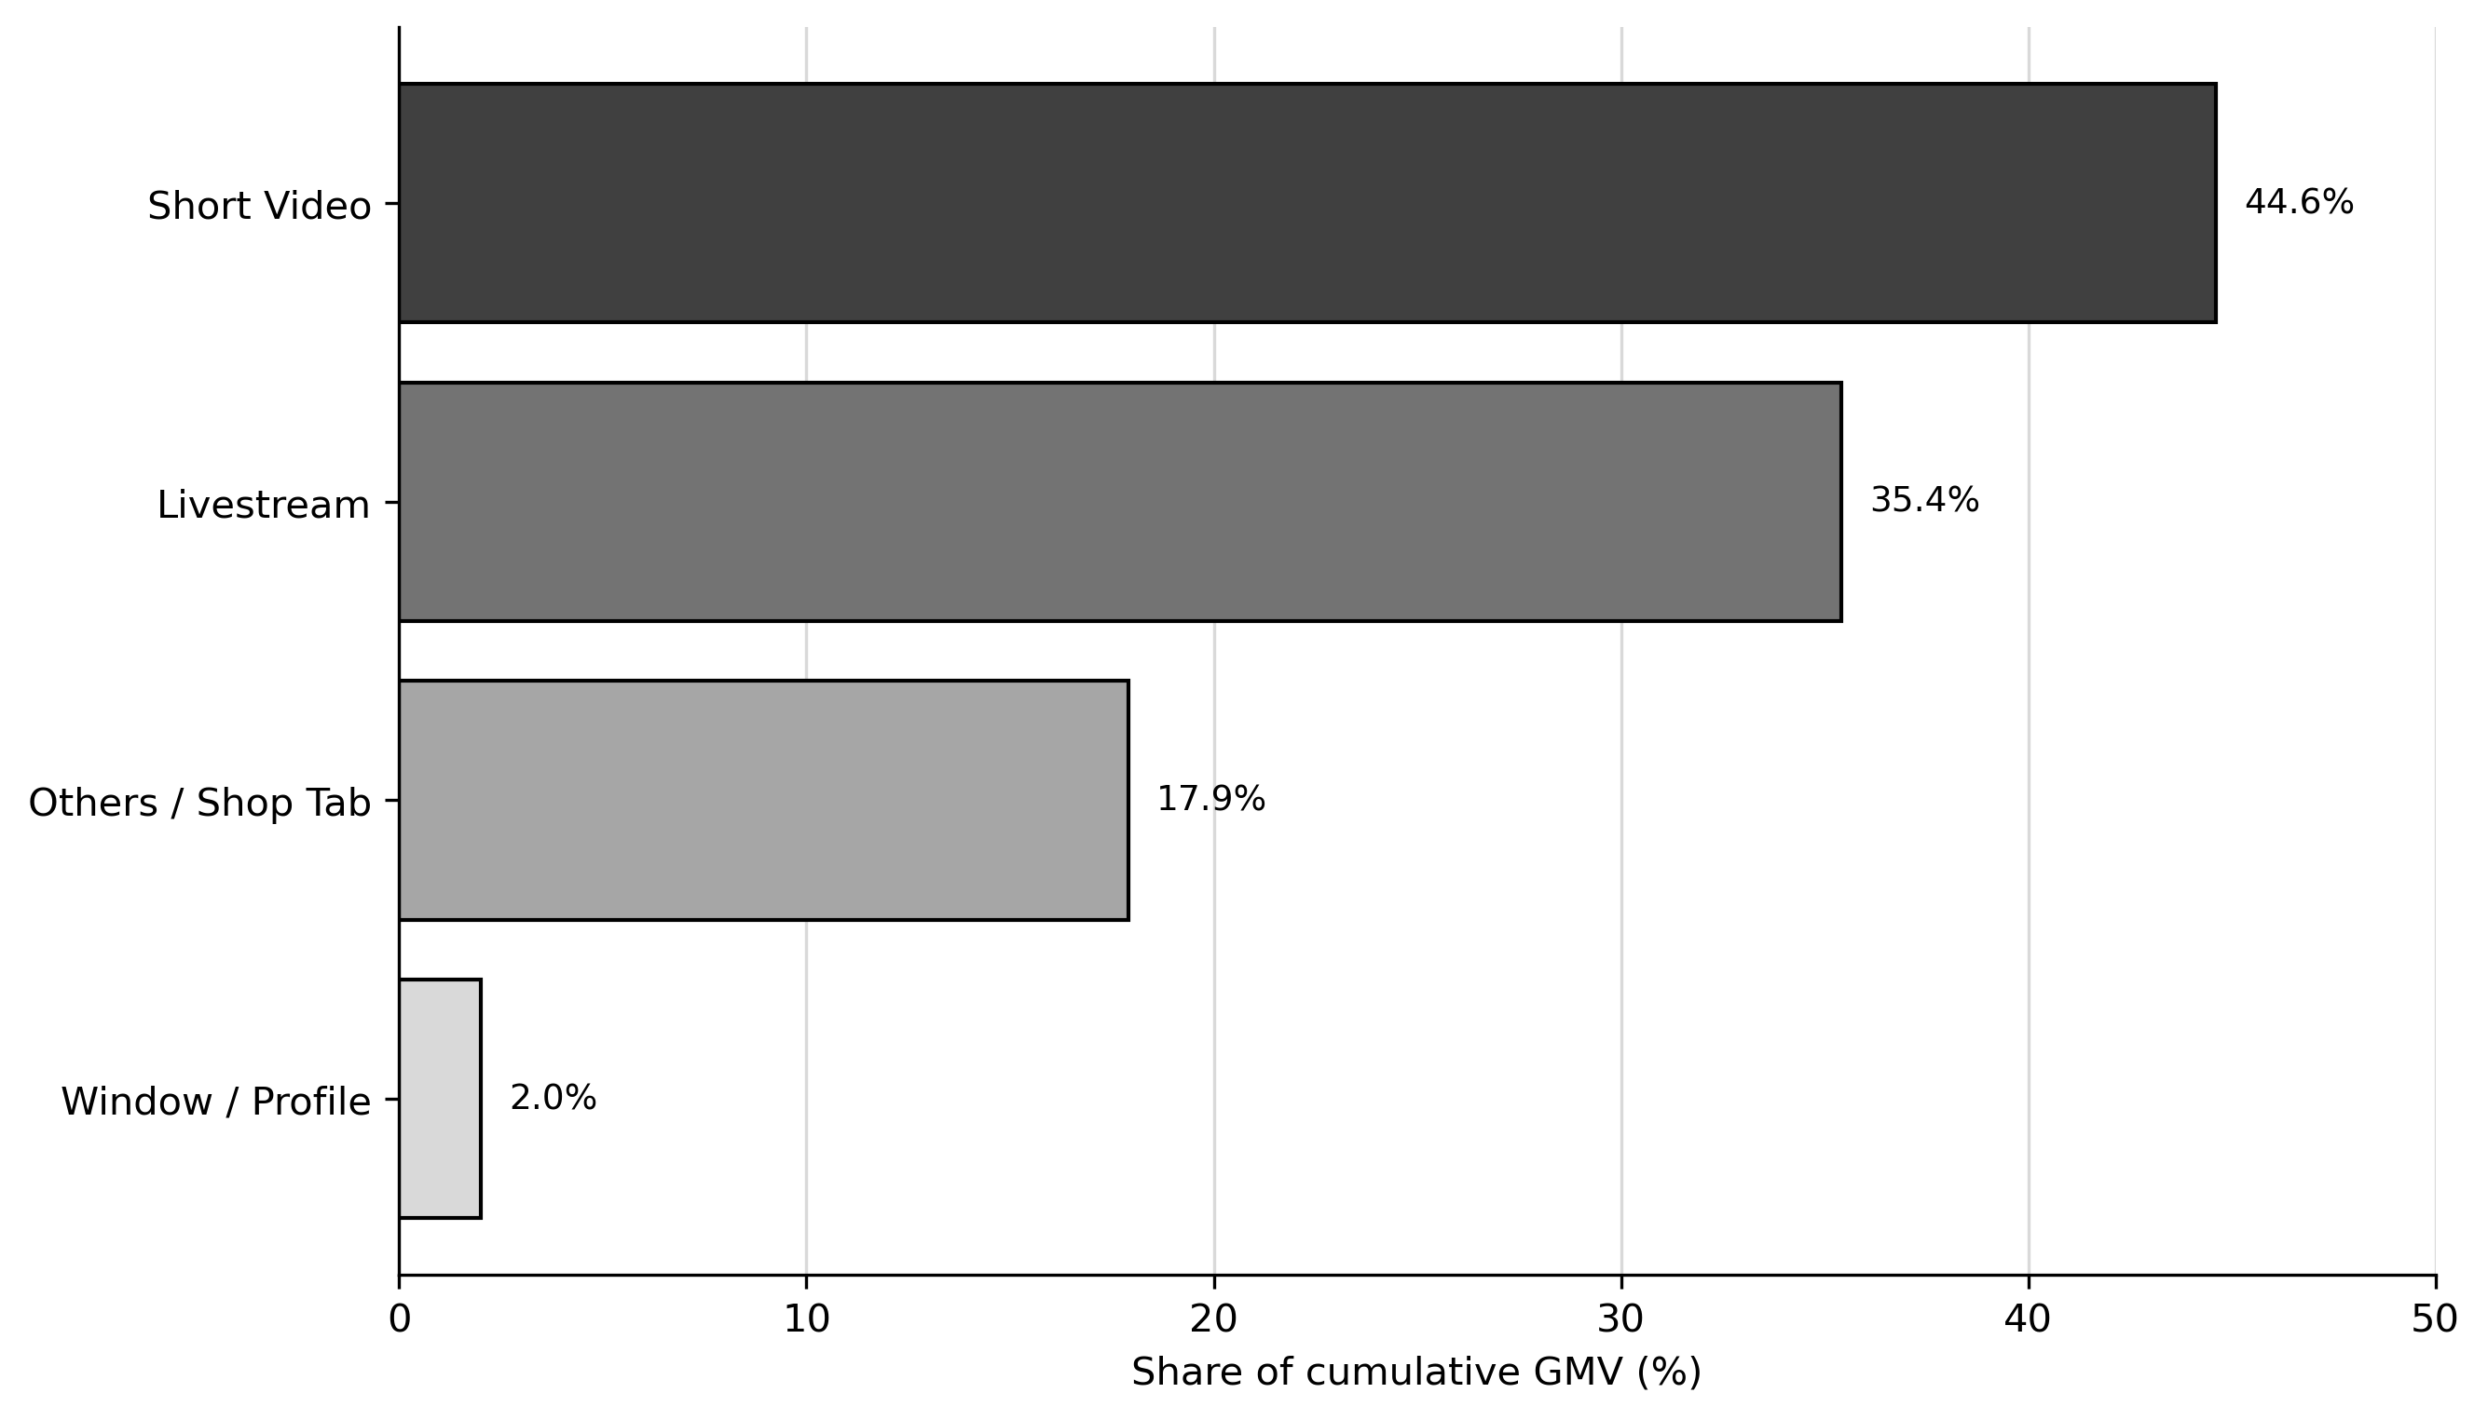
Figure 4. Sales Channel Distribution
Source: Appendix Table A3. These values reconcile with the monthly channel records; main Table 3 reports a conflicting allocation that remains unresolved and is retained for source verification.
Integrated discussion
Taken together, the reported findings portray digital transformation capability as a configuration rather than a single resource. The interpretation must remain bounded because the archived record establishes the direction and significance of the relationships but does not preserve path magnitudes or full structural-model diagnostics. Accordingly, the discussion explains why the relationships are theoretically plausible without ranking their importance or treating statistical significance as evidence of practical magnitude.
For H1, the positive relationship between adaptive content capability and agropreneurial performance is consistent with the RBV proposition that heterogeneous routines can generate different outcomes from broadly accessible technologies. Product knowledge, customer understanding and credible presentation are valuable only when organised into content that communicates an agro-product's provenance, preparation, quality and use. DCT adds the reason this relationship may persist in social commerce: audience feedback and platform conventions change, so entrepreneurs must repeatedly sense and reconfigure rather than reproduce a fixed content formula. Institutional conditions bound this adaptation because product claims, programme expectations and platform rules determine which forms of communication are legitimate and executable.
For H2, the positive relationship between platform capability utilisation and performance indicates that access is distinct from effective deployment. From an RBV perspective, the relevant resource is the seller's embedded routine for connecting discovery, product information, interaction, ordering and fulfilment. DCT explains platform utilisation as opportunity seizure and orchestration: entrepreneurs act on market signals by adjusting listings, campaigns, livestream schedules and transaction processes. Institutional Theory qualifies this process because platform governance allocates visibility and defines acceptable commercial conduct. The relationship therefore reflects capability exercised within a governed infrastructure, not unrestricted managerial control over the platform.
For H3, the positive relationship between institutional alignment capability and performance is compatible with the resources, legitimacy and structured learning available through a government-supported programme. Institutional Theory explains how entrepreneurs gain access by understanding programme and platform expectations; RBV explains why firms differ in their ability to internalise the same support; and DCT explains how guidance is translated into revised routines. This integrated reading avoids attributing the recorded GMV to FAMA alone. Stronger firms may be more able to engage with institutions, and unobserved product, logistics or experience advantages may influence both alignment and performance.
For H4, the reported significant indirect relationship provides the model's process explanation. Adaptive content may create relevance and attention, but those resources become commercially actionable only when platform functions connect the audience with product access and transaction. RBV identifies content knowledge as an input, DCT explains its conversion through platform-based sensing and seizure, and Institutional Theory specifies the rules and support conditions under which conversion occurs. Figure 5 visualises this mechanism. Because the indirect coefficient, confidence interval and direct effect were not retained, the mediation cannot be classified, its magnitude cannot be estimated, and chronological causality cannot be inferred.
The programme-level evidence complements this capability account but does not test the latent structural model. Monthly GMV increased from RM497,762.95 in June to RM1,705,942.05 in December, as shown in Figure 3. The trajectory may be compatible with accumulated execution capability, but campaigns, seasonality, seller activation and product availability are plausible alternatives. The sales-channel distribution in Figure 4 follows Appendix Table A3 because its components reconcile with the monthly records; the conflicting allocation in main Table 3 remains visible and requires validation against the primary FAMA export. No channel ranking should be treated as final until that reconciliation is completed.
The Malaysian setting makes the institutional boundary conditions especially visible. National digital and agrofood policies establish strategic direction, while AMTTSE connects a public agricultural-marketing agency, entrepreneurs and a global social-commerce platform [9-13]. Aggregate GMV indicates commercial scale, but seller activation, median performance, persistence and concentration are needed to establish whether capability formation is broad based. Public support may reduce entry barriers without eliminating heterogeneity arising from prior brand strength, product-market fit, working capital, logistics and entrepreneurial experience.
For international research, the findings contribute to understanding how platform ecosystems intersect with development institutions. Digital platforms can extend market reach, but capability deployment remains contingent on local logistics, sector regulation, products, skills and support organisations [21,23]. The evidence therefore supports analytical generalisation to comparable public-platform programmes rather than universal claims. The integrated framework is most useful as a testable explanation of how firm resources, adaptive processes and institutional conditions may combine, not as proof that the same relationships or magnitudes will hold across settings.
Potential Selection Bias and Institutional Context
Government-supported programme participation creates an empirical setting in which recruitment and institutional support may influence both the composition of the sample and the outcomes observed. The available record does not establish whether firms entered entirely through self-selection, agency nomination, regional referral or a combination of routes. Entrepreneurs volunteering for intensive social-commerce training may already possess stronger motivation, digital readiness or growth orientation than non-participants. Conversely, agency nomination may prioritise policy considerations such as regional inclusion, product categories or developmental need rather than prior commercial performance. These processes limit comparison with the wider population of Malaysian agropreneurs.
Selection criteria and regional representation also require cautious interpretation. Selangor accounts for 41.3% of participating companies, while several states are represented by one firm. Market proximity, connectivity, logistics and access to complementary services may therefore be unevenly distributed. It is also unknown from the surviving record whether FAMA selected firms with established products, fulfilment readiness or prior sales records. If higher-performing firms were more likely to be selected, programme outcomes could partly reflect pre-existing capability. If less-ready firms were intentionally included, aggregate outcomes may understate gains among firms facing larger initial constraints. Neither possibility can be resolved without baseline and non-participant data.
Public programmes may also operate within broader political and administrative priorities. Regional targets, inclusion objectives, stakeholder visibility and pressure to demonstrate programme performance can shape recruitment, monitoring and reporting without implying improper conduct by FAMA or participating firms. Headline GMV may be emphasised because it is readily auditable and policy-relevant, yet this can obscure inactive sellers, uneven value capture or costs not represented in gross transaction value. Survivorship bias may arise if firms that disengaged or failed to activate are less visible in final reports, while administrative reporting bias may arise from operational definitions, platform extraction rules or incomplete linkage across seller accounts.
These issues affect interpretation rather than invalidate the dataset. The findings describe associations within a bounded programme cohort and should not be read as an unbiased estimate of programme treatment effects or national agropreneur performance. Stronger future evaluation would document recruitment routes and eligibility criteria, retain pre-programme baselines, report all enrolled firms including zero-GMV participants, compare completers with non-completers, and where feasible construct an appropriate non-participant comparison group. Such safeguards would distinguish capability relationships from selection processes while preserving the legitimate developmental and inclusion objectives of government programme design.
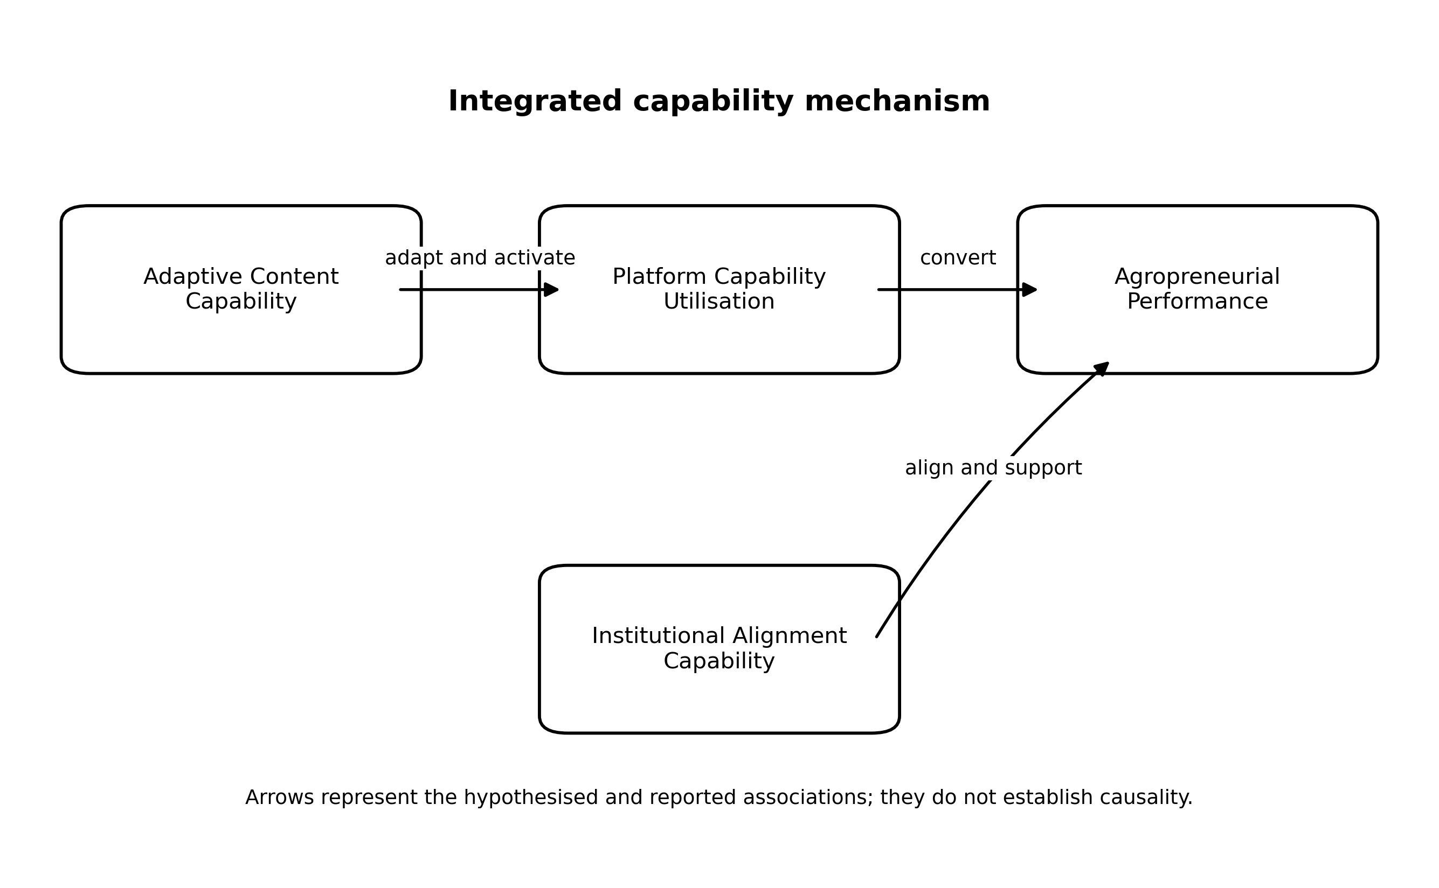
Figure 5. Integrated Capability Mechanism
Note: The figure illustrates the theoretical mediation logic without assigning unavailable path magnitudes.
4. Conclusion
Major findings and theoretical contributions
This study extends the RBV by showing how generally accessible platform infrastructure acquires strategic relevance through heterogeneous content and execution routines. It refines the application of Dynamic Capabilities Theory to content-led commerce by distinguishing adaptation from platform-based conversion, and it contextualises both perspectives through Institutional Theory in a government-supported entrepreneurship setting. The contribution is integrative rather than a claim that any constituent relationship is wholly new: the framework clarifies how internal resources, their continuing reconfiguration and external support or constraint can be considered together when interpreting agropreneurial performance.
The study also contributes to understanding seller-side capability in social commerce, a literature often centred on consumer intention, trust and engagement. In the agropreneurship context, it directs attention to downstream market conversion alongside the production-oriented concerns prominent in agricultural digitalisation research. The reported mediation relationship is consistent with platform utilisation acting as a link between adaptive content and performance; however, the unavailable effect magnitude and cross-sectional design require this contribution to be treated as a theoretically informed association rather than evidence of a causal sequence.
Contextually, the study documents how a public agency, a digital platform and participating firms interact within AMTTSE. This evidence may inform comparable capability-oriented programmes, while its implications remain bounded by the sample, institutional setting and archival limitations. The study therefore contributes to understanding rather than claiming universal applicability.
Practical and managerial implications
Entrepreneurs should treat content as part of an integrated commercial system. Posting frequency is insufficient unless product narratives, audience learning, platform features, pricing, inventory and fulfilment are coordinated. Short-video and livestream activities should be assessed through meaningful conversion indicators rather than volume alone. Entrepreneurs also need routines for reviewing performance data and reallocating effort toward formats and products that generate qualified engagement.
FAMA, SME Corp, MARDI and digital-training providers can use a staged capability model. Initial diagnostics should distinguish basic access, content readiness, platform execution and operational readiness. High-performing firms may require scaling and inventory support, while low- and zero-GMV firms require targeted diagnosis rather than repeated generic training. Higher education institutions can contribute through applied analytics, content experimentation and longitudinal evaluation. TikTok Shop can support programme quality through transparent seller analytics, sandbox practice and accessible guidance for diverse participant groups.
Managers should avoid evaluating the programme solely through cumulative GMV. A balanced dashboard should include active-seller rates, median seller performance, order fulfilment, customer retention, seller persistence after training and the distribution of value across participants. Such indicators protect against a small group of leading sellers masking weak conversion among the wider cohort.
Policy implications
The findings support the Malaysia Digital Economy Blueprint and National 4IR Policy by demonstrating that infrastructure and access must be accompanied by firm-level capability formation [9,10]. They also reinforce National Agrofood Policy objectives concerning modernisation and market access [13]. Future interventions should connect policy-level digitalisation targets with measurable seller-level capability and performance outcomes.
Public programmes should adopt evidence standards that distinguish participation, activation, conversion and persistence. Cost-effectiveness reporting should disclose the investment denominator and avoid equating GMV with profit. Platform partnerships should include data-governance provisions, transparent evaluation metrics and pathways for participants requiring additional support. Inclusive digitalisation requires attention to geographic concentration, PWD-owned enterprises and firms whose products or logistics are less immediately suited to content-led commerce.
Limitations and future research
Several limitations qualify the study. The cross-sectional, non-experimental design cannot establish temporal ordering or causal effects. Participation in a government-supported programme creates possible self-selection, agency-selection and survivorship biases, and the geographically uneven cohort may not represent Malaysian agropreneurs generally. The available record does not show whether recruitment favoured prior readiness or high-performing firms, and no baseline or non-participant comparison is available. Administrative data provide commercially grounded indicators but may reflect operational definitions, incomplete account linkage and reporting incentives; GMV is not profit, and the programme-reported 1:31 ratio depends on an undocumented cost denominator. Measurement limitations include the unavailable instrument wording, scale anchors, analytical unit and complete measurement-model archive. Most importantly for the second revision, the original SmartPLS structural output was not preserved: path coefficients, t-values, p-values, confidence intervals, R2, f2, Q2, SRMR and indirect-effect magnitude cannot be verified or reported. These constraints limit effect interpretation, mediation classification and generalisability beyond this programme, platform and country.
Future research should pursue six focused extensions. First, longitudinal capability research should measure constructs before, during and after programme participation to establish temporal ordering, capability persistence and whether GMV gains continue beyond campaign periods. This would address the present cross-sectional gap and clarify capability development rather than contemporaneous association.
Second, cross-platform comparison should examine otherwise comparable agropreneurs using TikTok Shop and alternative social-commerce or marketplace environments. Platform affordances and governance may alter the value of content and transaction routines; comparison would identify which relationships are platform-specific and which travel across digital infrastructures.
Third, research on AI-enabled digital capability should test how generative content tools, recommendation analytics and automated customer support complement or substitute for human adaptive routines. This would address an emerging capability gap and show whether AI widens performance differences or lowers barriers for resource-constrained firms.
Fourth, qualitative comparison of high- and low-performing agropreneurs, including zero-GMV participants, should trace how entrepreneurs interpret training, organise content, manage fulfilment and respond to failure. Such process evidence would explain the mechanisms and selection dynamics that aggregate administrative data cannot reveal.
Fifth, multilevel analysis should separate entrepreneur, firm, region, cohort, agency and platform influences. This would address clustering and contextual dependence in the present setting and clarify whether observed capability relationships originate mainly from individual routines, organisational resources or programme-level conditions.
Sixth, cross-country validation should test the integrated framework in public-platform agropreneurship programmes with different institutional systems, logistics and digital-market maturity. This would evaluate external validity and refine the institutional boundary conditions under which capability is associated with performance.
In conclusion, the available evidence suggests that agropreneurial performance in social commerce is associated with a configuration of adaptive content, platform utilisation and institutional alignment capabilities. The AMTTSE records indicate substantial aggregate commercial activity, while the uneven programme context and incomplete analytical archive require cautious interpretation. The relationships should not be read as causal effects, and the programme figures do not establish that capability gains were evenly distributed or persistent. A fuller assessment requires preserved structural-model output, transparent recruitment and baseline information, seller-level distribution measures and longitudinal follow-up.
Acknowledgement
Any grant did not fund this research.
Conflict of Interest Statement
The authors declare that there is no conflict of interest regarding the publication of this paper. No financial support, grants, or other forms of compensation were received that could have influenced the outcomes of this work.
Author Contributions Statement
Abd Razzif Abd Razak conceptualized the study and drafted the manuscript. The co-authors contributed to data interpretation, literature refinement, and manuscript revision.
Data Availability Statement
All data generated or analyzed during this study are included in this published article. Additional datasets are available from the corresponding author upon reasonable request.
Ethics Statement
This study was conducted in accordance with the ethical standards of the institutional and national research committee. Ethical approval was obtained where required, and informed consent was obtained from all participants involved in the research.
References
[1] Vial, G. (2019). Understanding digital transformation: A review and a research agenda. The Journal of Strategic Information Systems, 28(2), 118-144. https://doi.org/10.1016/j.jsis.2019.01.003
[2] Verhoef, P. C., Broekhuizen, T., Bart, Y., Bhattacharya, A., Dong, J. Q., Fabian, N., & Haenlein, M. (2021). Digital transformation: A multidisciplinary reflection and research agenda. Journal of Business Research, 122, 889-901. https://doi.org/10.1016/j.jbusres.2019.09.022
[3] Gong, C., & Ribiere, V. (2021). Developing a unified definition of digital transformation. Technovation, 102, 102217. https://doi.org/10.1016/j.technovation.2020.102217
[4] Hanelt, A., Bohnsack, R., Marz, D., & Antunes Marante, C. (2021). A systematic review of the literature on digital transformation. Journal of Management Studies, 58(5), 1159-1197. https://doi.org/10.1111/joms.12639
[5] Kraus, S., Durst, S., Ferreira, J. J., Veiga, P., Kailer, N., & Weinmann, A. (2022). Digital transformation in business and management research. International Journal of Information Management, 63, 102466. https://doi.org/10.1016/j.ijinfomgt.2021.102466
[6] Liao, Y., Deschamps, F., Loures, E. F. R., & Ramos, L. F. P. (2017). Past, present and future of Industry 4.0. International Journal of Production Research, 55(12), 3609-3629. https://doi.org/10.1080/00207543.2017.1308576
[7] Sony, M., & Naik, S. (2020). Critical factors for successful Industry 4.0 implementation. Production Planning & Control, 31(10), 799-815. https://doi.org/10.1080/09537287.2019.1691278
[8] Deguchi, A., Hirai, C., Matsuoka, H., Nakano, T., Oshima, K., Tai, M., & Tani, S. (2020). What is Society 5.0? In Society 5.0 (pp. 1-23). Springer. https://doi.org/10.1007/978-981-15-2989-4_1
[9] Economic Planning Unit. (2021). Malaysia Digital Economy Blueprint. Government of Malaysia.
[10] Economic Planning Unit. (2021). National Fourth Industrial Revolution (4IR) Policy. Government of Malaysia.
[11] Government of Malaysia. (2021). Twelfth Malaysia Plan, 2021-2025. Economic Planning Unit.
[12] Ministry of Investment, Trade and Industry. (2023). New Industrial Master Plan 2030. Government of Malaysia.
[13] Ministry of Agriculture and Food Industries. (2021). National Agrofood Policy 2021-2030. Government of Malaysia.
[14] Liang, T.-P., Ho, Y.-T., Li, Y.-W., & Turban, E. (2011). What drives social commerce. International Journal of Electronic Commerce, 16(2), 69-90. https://doi.org/10.2753/JEC1086-4415160204
[15] Hajli, N. (2015). Social commerce constructs and consumer's intention to buy. International Journal of Information Management, 35(2), 183-191. https://doi.org/10.1016/j.ijinfomgt.2014.12.005
[16] Sun, Y., Shao, X., Li, X., Guo, Y., & Nie, K. (2019). How live streaming influences purchase intentions in social commerce. Electronic Commerce Research and Applications, 37, 100886. https://doi.org/10.1016/j.elerap.2019.100886
[17] Wongkitrungrueng, A., & Assarut, N. (2020). The role of live streaming in building consumer trust and engagement. Journal of Business Research, 117, 543-556. https://doi.org/10.1016/j.jbusres.2018.08.032
[18] Zhang, M., Qin, F., Wang, G. A., & Luo, C. (2020). The impact of live video streaming on online purchase intention. The Service Industries Journal, 40(9-10), 656-681. https://doi.org/10.1080/02642069.2019.1576642
[19] Gao, X., Xu, X.-Y., Tayyab, S. M. U., & Li, Q. (2021). How live streaming commerce viewers process persuasive messages. Electronic Commerce Research and Applications, 49, 101087. https://doi.org/10.1016/j.elerap.2021.101087
[20] Lu, B., & Chen, Z. (2021). Live streaming commerce and consumers' purchase intention. Information & Management, 58(7), 103509. https://doi.org/10.1016/j.im.2021.103509
[21] Bonina, C., Koskinen, K., Eaton, B., & Gawer, A. (2021). Digital platforms for development. Information Systems Journal, 31(6), 869-902. https://doi.org/10.1111/isj.12326
[22] Cozzolino, A., Corbo, L., & Aversa, P. (2021). Digital platform-based ecosystems. Journal of Business Research, 126, 385-400. https://doi.org/10.1016/j.jbusres.2020.12.058
[23] Kapoor, K., Bigdeli, A. Z., Dwivedi, Y. K., Schroeder, A., Beltagui, A., & Baines, T. (2021). A socio-technical view of platform ecosystems. Journal of Business Research, 128, 94-108. https://doi.org/10.1016/j.jbusres.2021.01.060
[24] Chen, L., Tong, T. W., Tang, S., & Han, N. (2022). Governance and design of digital platforms. Journal of Management, 48(1), 147-184. https://doi.org/10.1177/01492063211045023
[25] Battisti, S., Agarwal, N., & Brem, A. (2022). Creating new tech entrepreneurs with digital platforms. Technological Forecasting and Social Change, 175, 121392. https://doi.org/10.1016/j.techfore.2021.121392
[26] Guo, L., Hu, X., Lu, J., & Ma, L. (2021). Effects of customer trust on engagement in live streaming commerce. Internet Research, 31(5), 1718-1744. https://doi.org/10.1108/INTR-02-2020-0078
[27] Wang, Y., Lu, Z., Cao, P., Chu, J., Wang, H., & Wattenhofer, R. (2022). How live streaming changes shopping decisions. Computer Supported Cooperative Work, 31(4), 701-729. https://doi.org/10.1007/s10606-022-09439-2
[28] Xue, J., & Liu, M. T. (2023). Investigating live streaming sales from the ecosystem perspective. Asia Pacific Journal of Marketing and Logistics, 35(5), 1157-1186. https://doi.org/10.1108/APJML-11-2021-0822
[29] Luo, X., Lim, W. M., Cheah, J.-H., Lim, X.-J., & Dwivedi, Y. K. (2025). Live streaming commerce: A review and research agenda. Journal of Computer Information Systems, 65(3), 376-399. https://doi.org/10.1080/08874417.2023.2290574
[30] Kim, J., He, N., & Miles, I. (2023). Live commerce platforms. Journal of Theoretical and Applied Electronic Commerce Research, 18(2), 959-975. https://doi.org/10.3390/jtaer18020049
[31] Rijswijk, K., Klerkx, L., Bacco, M., Bartolini, F., Bulten, E., Debruyne, L., Dessein, J., Scotti, I., & Brunori, G. (2021). Digital transformation of agriculture and rural areas. Journal of Rural Studies, 85, 79-90. https://doi.org/10.1016/j.jrurstud.2021.05.003
[32] Rajkhowa, P., & Qaim, M. (2021). Personalized digital extension services and agricultural performance. PLOS ONE, 16(10), e0259319. https://doi.org/10.1371/journal.pone.0259319
[33] Abdulai, A.-R., Quarshie, P. T., Duncan, E., & Fraser, E. (2023). Is agricultural digitization a reality among smallholder farmers in Africa? Agriculture & Food Security, 12(1). https://doi.org/10.1186/s40066-023-00416-6
[34] Miine, L. K., Akorsu, A. D., Boampong, O., & Bukari, S. (2023). Adoption of digital agricultural services by smallholder farmers. Heliyon, 9(12), e23023. https://doi.org/10.1016/j.heliyon.2023.e23023
[35] Choruma, D. J., Dirwai, T. L., Mutenje, M. J., Mustafa, M., Chimonyo, V. G. P., Jacobs-Mata, I., & Mabhaudhi, T. (2024). Digitalisation in agriculture. Journal of Agriculture and Food Research, 18, 101286. https://doi.org/10.1016/j.jafr.2024.101286
[36] Cheng, C., Gao, Q., Ju, K., & Ma, Y. (2024). How digital skills affect farmers' agricultural entrepreneurship. Journal of Innovation & Knowledge, 9(2), 100477. https://doi.org/10.1016/j.jik.2024.100477
[37] Hoang, H. G., & Tran, H. D. (2023). Smallholder farmers' adoption of digital agricultural technologies. Outlook on Agriculture, 52(4), 457-468. https://doi.org/10.1177/00307270231197825
[38] Ismail, I. J. (2023). Entrepreneurial networks, digital technology and smallholder market participation. Cogent Food & Agriculture, 9(1), 2171834. https://doi.org/10.1080/23311932.2023.2171834
[39] Nadkarni, S., & Prugl, R. (2021). Digital transformation: Review, synthesis and opportunities. Management Review Quarterly, 71, 233-341. https://doi.org/10.1007/s11301-020-00185-7
[40] Li, L., Su, F., Zhang, W., & Mao, J.-Y. (2018). Digital transformation by SME entrepreneurs. Information Systems Journal, 28(6), 1129-1157. https://doi.org/10.1111/isj.12153
[41] Eller, R., Alford, P., Kallmunzer, A., & Peters, M. (2020). Antecedents and consequences of SME digitalization. Journal of Business Research, 112, 119-127. https://doi.org/10.1016/j.jbusres.2020.03.004
[42] Scuotto, V., Nicotra, M., Del Giudice, M., Krueger, N., & Gregori, G. L. (2021). A microfoundational perspective on SMEs' growth. Journal of Business Research, 129, 382-392. https://doi.org/10.1016/j.jbusres.2021.01.045
[43] Canhoto, A. I., Quinton, S., Pera, R., Molinillo, S., & Simkin, L. (2021). Digital strategy aligning in SMEs. The Journal of Strategic Information Systems, 30(3), 101682. https://doi.org/10.1016/j.jsis.2021.101682
[44] Troise, C., Corvello, V., Ghobadian, A., & O'Regan, N. (2022). SMEs, agility and the digital transformation era. Technological Forecasting and Social Change, 174, 121227. https://doi.org/10.1016/j.techfore.2021.121227
[45] Borah, P. S., Iqbal, S., & Akhtar, S. (2022). Social media usage and SME sustainable performance. Technology in Society, 68, 101900. https://doi.org/10.1016/j.techsoc.2022.101900
[46] Merin-Rodriganez, J., Dasi, A., & Alegre, J. (2024). Digital transformation and firm performance in innovative SMEs. Technovation, 134, 103027. https://doi.org/10.1016/j.technovation.2024.103027
[47] Proksch, D., Rosin, A. F., Stubner, S., & Pinkwart, A. (2024). Digital strategy and digitalization of new ventures. Journal of Small Business Management, 62(1), 1-29. https://doi.org/10.1080/00472778.2021.1883036
[48] Omrani, N., Rejeb, N., Maalaoui, A., Dabic, M., & Kraus, S. (2024). Drivers of digital transformation in SMEs. IEEE Transactions on Engineering Management, 71, 5030-5043. https://doi.org/10.1109/TEM.2022.3215727
[49] Barney, J. (1991). Firm resources and sustained competitive advantage. Journal of Management, 17(1), 99-120. https://doi.org/10.1177/014920639101700108
[50] Teece, D. J., Pisano, G., & Shuen, A. (1997). Dynamic capabilities and strategic management. Strategic Management Journal, 18(7), 509-533.
[51] Eisenhardt, K. M., & Martin, J. A. (2000). Dynamic capabilities: What are they? Strategic Management Journal, 21(10-11), 1105-1121.
[52] Teece, D. J. (2007). Explicating dynamic capabilities. Strategic Management Journal, 28(13), 1319-1350. https://doi.org/10.1002/smj.640
[53] Warner, K. S. R., & Wager, M. (2019). Building dynamic capabilities for digital transformation. Long Range Planning, 52(3), 326-349. https://doi.org/10.1016/j.lrp.2018.12.001
[54] DiMaggio, P. J., & Powell, W. W. (1983). The iron cage revisited. American Sociological Review, 48(2), 147-160. https://doi.org/10.2307/2095101
[55] Hinings, B., Gegenhuber, T., & Greenwood, R. (2018). Digital innovation and transformation. Information and Organization, 28(1), 52-61. https://doi.org/10.1016/j.infoandorg.2018.02.004
[56] Sendra-Pons, P., Comeig, I., & Mas-Tur, A. (2022). Institutional factors affecting entrepreneurship. European Research on Management and Business Economics, 28(3), 100187. https://doi.org/10.1016/j.iedeen.2021.100187
[57] Hair, J. F., Risher, J. J., Sarstedt, M., & Ringle, C. M. (2019). When to use and how to report PLS-SEM. European Business Review, 31(1), 2-24. https://doi.org/10.1108/EBR-11-2018-0203
[58] Hair, J. F., Hult, G. T. M., Ringle, C. M., & Sarstedt, M. (2022). A Primer on Partial Least Squares Structural Equation Modeling (3rd ed.). SAGE.
[59] Nitzl, C., Roldan, J. L., & Cepeda, G. (2016). Mediation analysis in partial least squares path modeling. Industrial Management & Data Systems, 116(9), 1849-1864. https://doi.org/10.1108/IMDS-07-2015-0302
[60] Henseler, J., Ringle, C. M., & Sarstedt, M. (2015). A new criterion for assessing discriminant validity. Journal of the Academy of Marketing Science, 43(1), 115-135. https://doi.org/10.1007/s11747-014-0403-8
[61] Shmueli, G., Sarstedt, M., Hair, J. F., Cheah, J.-H., Ting, H., Vaithilingam, S., & Ringle, C. M. (2019). Predictive model assessment in PLS-SEM. European Journal of Marketing, 53(11), 2322-2347. https://doi.org/10.1108/EJM-02-2019-0189
[62] Federal Agricultural Marketing Authority. (2024). FAMA TikTok Shop Performance Report: Agromarketing Masterclass TikTok Shop Edition [Unpublished administrative programme report].
Appendix A. Extended Evidence From the Source Programme Dataset
The appendix retains the original source-programme evidence and numbering. It separates operational records from the latent capability model and provides additional context for interpreting programme scale, monthly movement, channel allocation, seller concentration and exploratory correlations.
A1
Data Collection Process
Stage | Process | Data Output
1 | Programme recruitment and registration of FAMA entrepreneurs | List of participating companies and seller identifiers
2 | Training delivery through AMTTSE | Training cohort and batch information
3 | TikTok Shop activation and product listing | Shop code, SKU and seller readiness information
4 | June-December monitoring period | Monthly channel sales, product movement, content and order records
5 | Performance extraction | Summary GMV, seller GMV and channel-based sales
6 | Verification and cleaning | Removal of duplicated totals and validation of numerical values
7 | Statistical analysis | Descriptive statistics and Pearson correlation using monthly aggregate records
8 | Interpretation | Theoretical, policy and industry implications
Table A1 distinguishes programme enrolment, platform activation and commercial outcomes. This staged process is important because participation is not equivalent to measurable digital conversion.
A2
Monthly Programme Performance
Month | Total Sales (RM) | Livestream (RM) | Short Video (RM) | Products Sold | Orders
June | 497,762.95 | 194,759.55 | 180,940.23 | 21,280 | 3,271
July | 507,967.92 | 174,190.65 | 193,101.29 | 22,298 | 3,381
August | 728,225.46 | 259,453.12 | 300,783.08 | 34,583 | 4,645
September | 692,259.02 | 263,009.12 | 263,940.70 | 25,617 | 7,159
October | 814,482.14 | 323,530.03 | 317,551.16 | 32,334 | 6,164
November | 1,259,317.52 | 402,162.25 | 638,313.61 | 37,804 | 10,194
December | 1,705,942.05 | 582,847.27 | 871,599.37 | 45,192 | 14,571
Table A2 records an upward aggregate trajectory culminating in December. The pattern does not by itself establish learning, sustainability or causal programme impact because seasonal and campaign effects were not isolated.
A3
Sales by Channel
Channel | June-Dec Sales (RM) | Share of Total (%)
Livestream | 2,199,951.99 | 35.4
Short Video | 2,766,229.44 | 44.6
Window/Profile | 127,020.07 | 2.0
Others/Shop Tab | 1,112,755.54 | 17.9
Total | 6,205,957.06 | 100.0
Table A3 identifies short video as the largest channel in the appendix source. Its conflict with main Table 3 is disclosed rather than silently corrected and requires validation against the primary export.
A4
Top Sellers by GMV
Rank | Shop Name | Batch | SOF | OKU | GMV (RM)
1 | CHEF USTAZAH HQ | Batch 2 | N | No | 689,517.94
2 | kerepek azharfood | Batch 1 | N | No | 533,945.85
3 | Munif Cocoa@ Koko Spread Sedap | Batch 1 | N | No | 173,804.07
4 | DASTO HQ | Batch 2 | N | No | 107,254.26
5 | Dapur Pak Amir | Batch 1 | N | Yes | 39,562.30
6 | Baja Taiping | Batch 2 | N | No | 37,368.97
7 | Ayamhalalbismi | Batch 1 | Y | No | 20,120.58
8 | RIZQ MART | Batch 1 | Y | Yes | 15,701.73
9 | Corndog Anak Ramai HQ | Batch 2 | Y | No | 10,396.60
10 | agromasmalaysia | Batch 1 | N | No | 9,817.92
Table A4 shows substantial seller heterogeneity. The reporting period for these values should be confirmed before deriving concentration measures or comparing them with cumulative programme GMV.
A5
Correlation Analysis
Indicator | Pearson r | p-value | Significance
Livestream sales (RM) | 0.989 | <.0001 | **
Short-video sales (RM) | 0.997 | <.0001 | **
Profile/window sales (RM) | 0.971 | 0.0003 | **
Other/shop-tab sales (RM) | 0.972 | 0.0002 | **
Live-stream content volume | 0.720 | 0.0683 | ns
Short-video content volume | 0.414 | 0.3556 | ns
Total content volume | 0.538 | 0.2133 | ns
Products sold | 0.930 | 0.0024 | **
Products for sale | -0.011 | 0.9807 | ns
Orders | 0.977 | 0.0002 | **
Table A5 is exploratory because it uses seven aggregate monthly observations. Correlations between channel sales and total sales are additionally affected by part-whole construction and do not test the latent capability hypotheses.
A6
Summary of AMTTSE Performance Report
No. | Item | Description / Value
1 | Number of Companies | 80
2 | Number of Participants | 160
3 | Training Courses Conducted | 2
4 | Fresh Product Companies | 11
5 | Processed Product Companies | 69
6 | SKUs Marketed | 425
7 | PWD-Owned Companies | 13
8 | 2-hour Live Sales (June 2024) | RM12,657.15
9 | 2-hour Live Sales (July 2024) | RM4,274.31
10 | December 2024 Sales | RM1,705,942.05
11 | Cumulative Sales (June-December 2024) | RM6,205,957.06
12 | Return on Investment | 1:31 - programme-reported ratio
Table A6 provides a management summary of reach, product mix and recorded output. The return ratio requires the programme costing method before it can be interpreted as conventional ROI.
A7. Managerial Implications and Recommendations
Future cohorts should connect short-video and livestream capability with product readiness, platform execution and fulfilment. Programme administrators should identify low- and zero-GMV sellers early and provide differentiated coaching. Evaluation should track activation, median performance, persistence and seller-level distribution rather than relying only on cumulative sales. For researchers, the evidence reinforces the distinction between content volume and monetised activity and supports longitudinal, seller-level investigation of digital capability conversion.

