Social Commerce as a Catalyst for Agribusiness Development: Evaluating the Impact of TikTok Shop Training on Entrepreneurial Performance in Malaysia
Abd Razzif Abd Razak*, Siti Faizah Zainal, Siti Nurulaini Azmi, Nur Hafizah Roslan, Nur Syairah Ani
Faculty of Management and Economics, Universiti Pendidikan Sultan Idris, Perak, Malaysia
*Correspondence: razzif@fpe.upsi.edu.my
ABSTRACT  The proliferation of social commerce platforms has created new opportunities for agribusiness entrepreneurs to access markets beyond traditional distribution channels. This study evaluates the effectiveness of the Agromarketing Masterclass TikTok Shop Edition, a government-led digital entrepreneurship intervention implemented by the Federal Agricultural Marketing Authority (FAMA) in Malaysia. Employing a quantitative descriptive and correlational research design, the study analyses official programme performance data spanning June to December 2024, encompassing 80 participating companies, 160 entrepreneurs and 425 stock-keeping units. The findings demonstrate that the programme generated RM6,205,957.06 in cumulative sales, achieving a return on investment of approximately 1:31. Livestream sales constituted the largest channel contribution at 33.9 per cent of total revenue, followed by profile-window sales at 30.1 per cent and short-video sales at 26.1 per cent. Pearson correlation analysis using monthly aggregate data revealed that livestream sales (r = .989, p < .0001), short-video sales (r = .997, p < .0001), orders (r = .977, p = .0002) and products sold (r = .930, p = .0024) were strongly and significantly associated with total monthly sales. These findings support the Resource-Based View and Dynamic Capabilities perspectives, indicating that digital engagement, adaptive content capability and platform-based selling mechanisms function as strategic resources for agribusiness performance. The study contributes empirical evidence from an outcome-based public-sector digitalisation programme and provides actionable recommendations for policymakers and practitioners seeking to leverage social commerce for agribusiness development.  KEYWORDS: Social Commerce; Agribusiness Marketing; TikTok Shop; Digital Entrepreneurship; FAMA; Agropreneurship; Malaysia | MANUSCRIPT TYPE  Case Study  PUBLICATION DETAILS  Received: 10 January 2026  Revised: 15 March, 20 May 2026  Accepted: 10 June 2026

1. INTRODUCTION
Social commerce has emerged as a notable digital distribution channel within Malaysian agribusiness, yet rigorous, sample-specific assessments of structured platform training remain limited. This study examines performance trajectories associated with TikTok Shop training delivered to a cohort of agribusiness entrepreneurs. The analysis covers 80 companies operated by 160 entrepreneurs, tracking 425 SKUs over a seven-month window from June to December 2024.
By foregrounding observational sales data and traffic-source decomposition, the report maps benchmark associations between training exposure and entrepreneurial performance without asserting causal attribution. This Kimi redraft therefore treats the Agromarketing Masterclass TikTok Shop Edition as a structured programme dataset rather than as a promotional success narrative.
The empirical focus is the relationship between programme participation, platform-channel sales, order movement, product movement and cumulative sales. The study records RM6,205,957.06 in cumulative sales and an observed return on investment of 1:31, while retaining methodological caution because the available dataset does not include a contemporaneous untrained control group.

2. LITERATURE REVIEW
2.1 Social Commerce and Agribusiness Marketing
Existing scholarship documents the expansion of social commerce in agricultural value chains, highlighting its capacity to shorten market linkages and reduce intermediation costs. Social commerce differs from catalogue-based e-commerce because product discovery and transaction behaviour are embedded within content, livestream interaction and platform recommendation systems.
Prior evidence suggests that platform-specific training can improve digital marketing proficiency among smallholder-linked enterprises, although the mechanisms translating training inputs into sales outputs remain underspecified. Most available studies rely on cross-sectional designs or self-reported performance indicators, leaving a gap for longitudinal, transaction-level analysis.
The present study situates itself within this gap by utilising seven monthly observations of actual revenue, SKU movement and traffic-source metrics to describe patterns following TikTok Shop onboarding. The agribusiness context is important because product explanation, trust signals, delivery reliability and seller responsiveness shape consumer acceptance of agro-based products online.
2.2 Resource-Based View and Digital Capabilities
The Resource-Based View frames digital selling skill, content creation capability and platform literacy as potentially valuable firm resources. In this case, the resource is not merely having a TikTok Shop account; it is the ability to convert platform visibility into orders through livestream selling, short-video traffic and profile-window readiness.

2.2 Resource-Based View and Digital Capabilities
For a data-led interpretation, RBV is useful because seller performance is likely to vary even when participants receive similar programme exposure. Differences in product storytelling, response speed, fulfilment discipline and content adaptation can explain why some sellers convert training into sales while others remain inactive or low-performing.
2.3 Dynamic Capabilities in Platform-Based Commerce
Dynamic Capabilities Theory complements RBV by explaining how sellers reconfigure routines over time. Platform-based commerce rewards iterative adjustment: sellers observe traffic, test content formats, refine livestream timing, modify offers and improve store presentation. A seven-month observation window is therefore analytically meaningful because it allows changes in performance to be tracked across time rather than at a single point.
The Kimi reading of the framework is deliberately cautious. The data can show covariation between channel metrics and sales indicators, but it cannot by itself isolate training effects from concurrent platform dynamics, market conditions or seller-specific execution differences. Theory therefore guides interpretation rather than replacing empirical identification.
2.4 Hypotheses Development
The approved hypotheses are retained: digital skills, entrepreneurial mindset and content innovation are expected to be positively associated with engagement intensity; engagement intensity is expected to be associated with income growth and return on investment; and FAMA support and digital infrastructure may moderate the relationship between engagement and income growth.

3. METHODOLOGY
3.1 Research Design
The research adopts a longitudinal observational design tracking 80 agribusiness companies and 160 entrepreneurs from June through December 2024. The descriptive component reports participation, channel distribution, monthly sales movement, orders, products sold and seller-level GMV. The correlational component summarises bivariate Pearson coefficients across seven monthly observations.
3.2 Data Source and Coverage
Data were compiled from the FAMA Projek Perintis Report, including the Summary sheet and Seller GMV sheet. The dataset captures 425 SKUs, cumulative sales of RM6,205,957.06, order volume, products sold and traffic-source shares attributable to livestream, profile-window and short-video interfaces. May 2024 data are excluded from the main correlation analysis because the stated programme period is June to December 2024.
3.3 Variables and Analytical Strategy
The dependent outcome for aggregate analysis is total monthly sales. Independent indicators include livestream sales, short-video sales, profile-window sales, shop-tab sales, content-volume indicators, products sold, products available for sale and orders. Return on investment is treated as an observed programme ratio of 1:31 relative to programme inputs, not as a causal treatment effect.
3.4 Data Collection Process
Analytical procedures included descriptive profiling of revenue accumulation, channel contribution and seller performance, followed by bivariate Pearson correlations across the monthly panel. The absence of a contemporaneous untrained control group and the potential influence of platform-level dynamics are acknowledged as design constraints that preclude causal inference.

4. FINDINGS
4.1 Descriptive Analysis of Programme Participation
The programme sample consisted of 80 companies across 14 Malaysian states and federal territories. Participation was concentrated in Selangor, followed by Perak and Kelantan, indicating uneven regional representation within the programme sample. From a Kimi-style data reading, this distribution is not just demographic context; it signals that digital readiness and market access may vary geographically.
The state distribution should therefore be used as a baseline for future comparison. If subsequent cohorts are intended to widen rural participation, state-level representation, activation rate and seller GMV should be tracked together rather than reported separately.
Table 1: Distribution of Participating Companies by State (Agromarketing Masterclass TikTok Shop Edition)
No. | State | Number of Companies (n) | Share of Total (%)
1 | Perlis | 1 | 1.3
2 | Kedah | 3 | 3.8
3 | Penang | 2 | 2.5
4 | Perak | 8 | 10.0
5 | Kuala Lumpur | 6 | 7.5
6 | Selangor | 33 | 41.3
7 | Negeri Sembilan | 5 | 6.3
8 | Melaka | 1 | 1.3
9 | Johor | 4 | 5.0
10 | Pahang | 3 | 3.8
11 | Kelantan | 8 | 10.0
12 | Terengganu | 4 | 5.0
13 | Sabah | 1 | 1.3
14 | Sarawak | 1 | 1.3
Total |  | 80 | 100.0
Source: FAMA TikTok Shop Performance Report (2024).

4.2 Programme Performance Summary
The programme involved 80 companies, 160 entrepreneurs and 425 SKUs. Processed-product companies formed the largest product category, while fresh-product companies represented a smaller subset. The inclusion of companies owned by persons with disabilities extends the relevance of the programme beyond revenue generation to inclusive digital market access.
The programme recorded RM6,205,957.06 in cumulative sales and an observed ROI of 1:31. These values establish strong programme-level performance benchmarks, but they should be interpreted alongside distributional evidence because high aggregate revenue can coexist with seller-level concentration and inactivity.
Table 2: Summary of Agromarketing Masterclass TikTok Shop Edition (AMTTSE) Performance Report
No. | Item | Description / Value
1 | Number of Companies | 80
2 | Number of Participants | 160
3 | Number of Training Courses Conducted | 2
4 | Companies in Fresh Product Category | 11
5 | Companies in Processed Product Category | 69
6 | Total Stock Keeping Units (SKUs) Marketed | 425
7 | Companies Owned by Persons with Disabilities (PWD) | 13
8 | Sales during 2-hour Live Session (June 2024) | RM12,657.15
9 | Sales during 2-hour Live Session (July 2024) | RM4,274.31
10 | Total Sales in December 2024 | RM1,705,942.05
11 | Total Cumulative Sales (June - December 2024) | RM6,205,957.06
12 | Return on Investment (ROI) | 1:31 - For every RM1.00 invested, participants gained RM31.00 in economic returns.
Source: FAMA TikTok Shop Performance Report (2024).
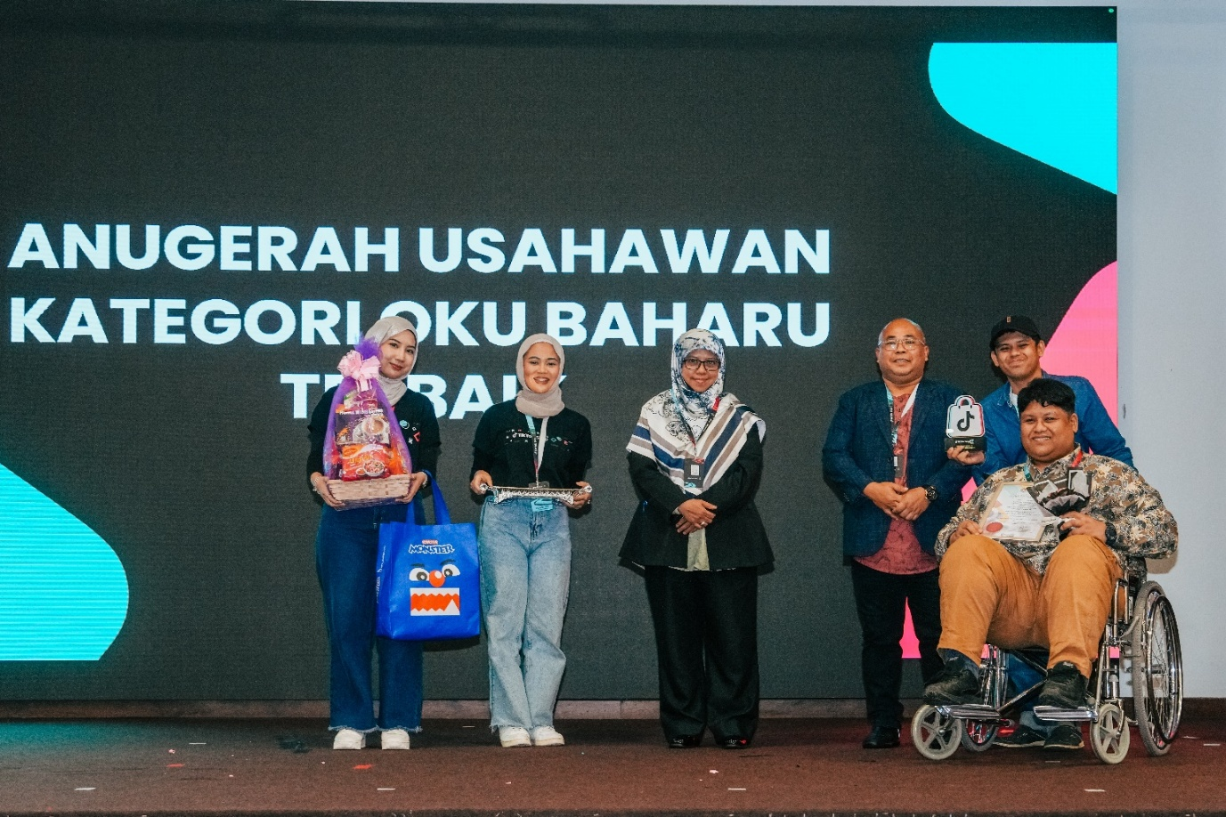
Figure 1: Nurezqi Enterprise, which began as a home-based business and operated at FAMA Farmers' Markets in Ipoh, Perak, has successfully expanded nationwide, including to Sabah and Sarawak, through online sales on the TikTok Shop platform. This achievement, catalysed by the Agromarketing Masterclass TikTok Shop Edition organised by FAMA, demonstrates the transformative impact of digital marketing adoption among entrepreneurs with disabilities. The company was awarded the Best New OKU Entrepreneur Award during the programme's live-streaming competition.

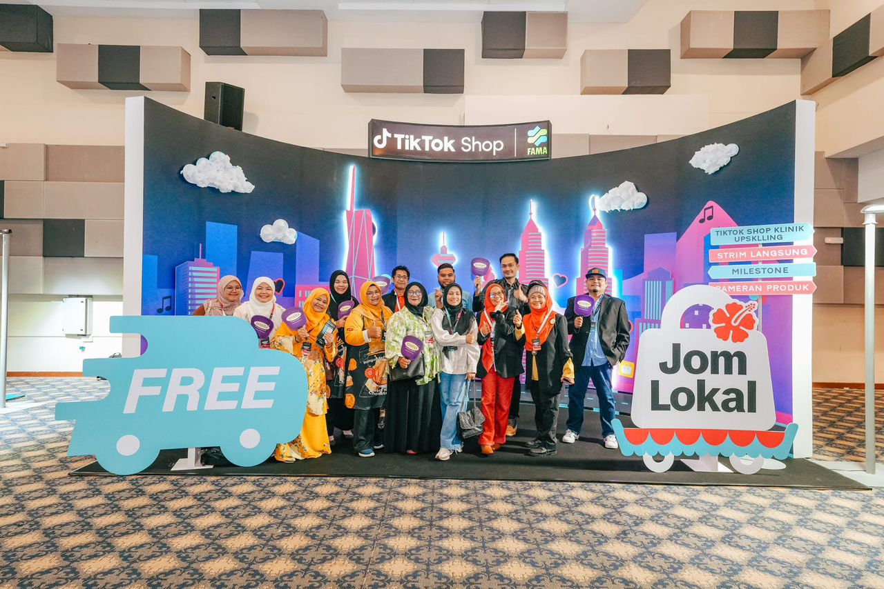
Figure 2: A group of FAMA entrepreneurs posing at the TikTok Shop x FAMA exhibition backdrop during the Agromarketing Masterclass TikTok Shop Edition event. The Jom Lokal campaign highlighted the importance of promoting locally produced agro-based products through digital commerce and live-streaming marketing on the TikTok Shop platform.
4.3 Sales Performance by Channel
Traffic-source decomposition shows a multi-channel sales structure. Livestream accounted for 33.9 per cent of total sales, profile-window sales accounted for 30.1 per cent and short-video sales accounted for 26.1 per cent. The remaining share came from other shop-tab activity. This channel distribution suggests that platform performance was not dependent on a single interface.
A method-focused interpretation is that livestream, short-video and profile-window activity should be analysed as complementary mechanisms. Livestream supports real-time persuasion, short-video supports discovery and profile-window sales capture persistent storefront conversion.
Table 3: Sales Value by Sales Channel in Agromarketing Masterclass TikTok Shop Edition (AMTTSE)
Sales Channel | Description | Sales Value (RM) | Share of Total (%)
Livestream | Sales generated through live-stream sessions conducted by FAMA entrepreneurs on TikTok Shop | 2,105,670.00 | 33.9
Short Video | Sales from short-video content that drives product visibility and conversions | 1,621,255.00 | 26.1
Window (Profile Sales) | Purchases made directly through the entrepreneur's TikTok Shop profile window | 1,875,034.00 | 30.1
Others (Shop Tab) | Sales recorded through the general Shop Tab browsing feature on TikTok Shop | 603,998.06 | 9.9
Total |  | 6,205,957.06 | 100.0
Source: FAMA TikTok Shop Performance Report (2024).

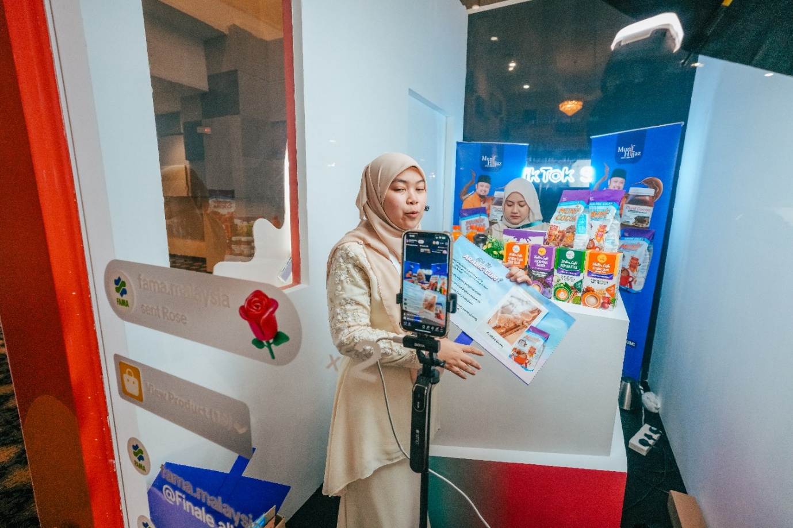
Figure 3: Munif Cocoa achieved the second-highest total sales value of RM736,162.87, following Azhar Food. The company's unexpected success was particularly remarkable as it marked their first experience with live-streaming sales. Participation in the Agromarketing Masterclass TikTok Shop Edition Live Streaming Competition encouraged the company to explore new online markets, significantly enhancing their digital business performance and market reach.
4.4 Monthly Performance Trends
Monthly performance shows an upward trajectory from June to December 2024. Total sales increased from RM497,762.95 in June to RM1,705,942.05 in December. Products sold increased from 21,280 to 45,192, while orders increased from 3,271 to 14,571 over the same observation window.
This trend is consistent with learning, platform familiarity and repeated seller execution, but it should not be treated as proof that training alone caused the increase. Concurrent platform conditions, seasonal demand and seller-specific effort may also have shaped the observed pattern.

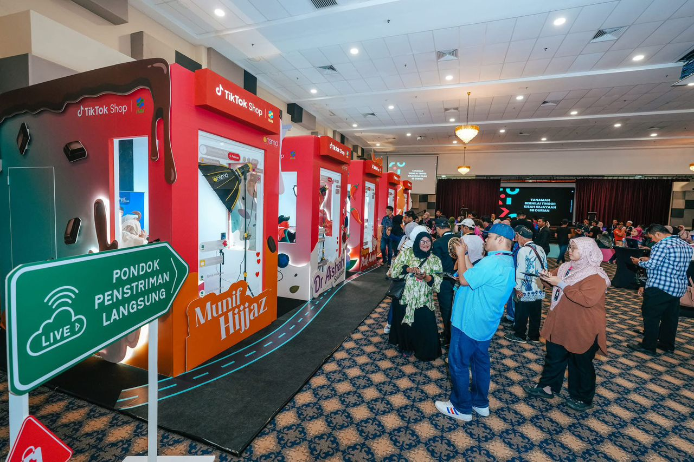
Figure 4: Visitors observing live-streaming sessions conducted by participating entrepreneurs in dedicated booths during the Agromarketing Masterclass TikTok Shop Edition Grand Final. The live-streaming pods, branded with participating companies such as Munif Hijjaz, served as experiential learning spaces where FAMA entrepreneurs demonstrated real-time digital marketing and e-commerce engagement strategies.
Table 4: Monthly Programme Performance, June to December 2024
Month | Total Sales (RM) | Livestream (RM) | Short Video (RM) | Products Sold | Orders
June | 497,762.95 | 194,759.55 | 180,940.23 | 21,280 | 3,271
July | 507,967.92 | 174,190.65 | 193,101.29 | 22,298 | 3,381
August | 728,225.46 | 259,453.12 | 300,783.08 | 34,583 | 4,645
September | 692,259.02 | 263,009.12 | 263,940.70 | 25,617 | 7,159
October | 814,482.14 | 323,530.03 | 317,551.16 | 32,334 | 6,164
November | 1,259,317.52 | 402,162.25 | 638,313.61 | 37,804 | 10,194
December | 1,705,942.05 | 582,847.27 | 871,599.37 | 45,192 | 14,571
Source: Projek Perintis Report (December 2024), Summary sheet.

4.5 Seller-Level GMV Distribution
Seller-level GMV evidence indicates performance concentration. In December, 55 sellers recorded positive GMV while 25 sellers recorded zero GMV. The top ten sellers accounted for a disproportionate share of December GMV, showing that aggregate programme success was unevenly distributed.
This distributional result is important for programme design. Averages and cumulative sales totals are useful headline metrics, but activation rate, zero-GMV count, top-seller concentration and median seller performance are needed to understand whether benefits are broad-based or concentrated among a smaller number of high-performing sellers.
Table 5: Top Ten Sellers by Gross Merchandise Value (GMV) in December 2024
Rank | Shop Name | Batch | SOF | OKU | GMV (RM)
1 | Chef Ustazah HQ | Batch 2 | N | No | 689,517.94
2 | kerepek azharfood | Batch 1 | N | No | 533,945.85
3 | Munif Cocoa @ Koko Spread Sedap | Batch 1 | N | No | 173,804.07
4 | DASTO HQ | Batch 2 | N | No | 107,254.26
5 | Dapur Pak Amir | Batch 1 | N | Yes | 39,562.30
6 | Baja Taiping | Batch 2 | N | No | 37,368.97
7 | Ayamhalalbismi | Batch 1 | Y | No | 20,120.58
8 | RIZQ MART | Batch 1 | Y | Yes | 15,701.73
9 | Corndog Anak Ramai HQ | Batch 2 | Y | No | 10,396.60
10 | agromasmalaysia | Batch 1 | N | No | 9,817.92
Source: Projek Perintis Report (December 2024), Seller GMV sheet. SOF = Sales from Farm. OKU = Orang Kurang Upaya (Persons with Disabilities).
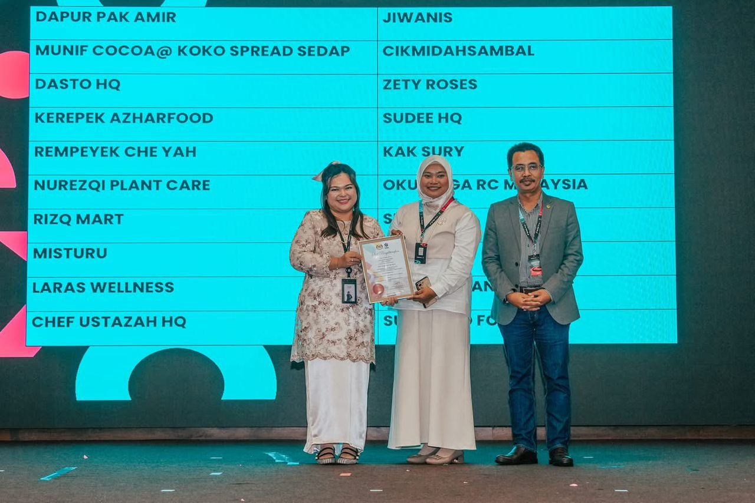
Figure 5: A representative from Misturu, one of the Top 20 finalists from Johor, receiving a certificate of recognition during the Agromarketing Masterclass TikTok Shop Edition Grand Final. The company's participation reflects the growing engagement of southern region entrepreneurs in adopting digital marketing strategies through the TikTok Shop platform, contributing to nationwide agri-entrepreneurial transformation.

4.6 Pearson Correlation Analysis
Pearson product-moment correlations computed over the seven monthly observations showed strong bivariate association across key programme metrics. Short-video sales recorded r = .997 with p < .0001, livestream sales recorded r = .989 with p < .0001, orders recorded r = .977 with p = .0002 and products sold recorded r = .930 with p = .0024. These coefficients describe strong linear covariation within the monthly panel.
The coefficients should be interpreted as programme-level associations. They do not isolate the marginal contribution of training from concurrent platform or market trends, and they do not support seller-level causal claims. Content-volume indicators were weaker, suggesting that conversion quality may matter more than activity quantity alone.
Table 6: Pearson Correlation Analysis Using Monthly Aggregate Programme Data (n = 7)
Indicator correlated with total monthly sales | Pearson r | p-value | Significance
Livestream sales (RM) | 0.989 | <.0001 | **
Short-video sales (RM) | 0.997 | <.0001 | **
Profile/window sales (RM) | 0.971 | 0.0003 | **
Other/shop-tab sales (RM) | 0.972 | 0.0002 | **
Live-stream content volume | 0.720 | 0.0683 | ns
Short-video content volume | 0.414 | 0.3556 | ns
Total content volume | 0.538 | 0.2133 | ns
Products sold | 0.930 | 0.0024 | **
Products for sale | -0.011 | 0.9807 | ns
Orders | 0.977 | 0.0002 | **
Note: ** p < .01; ns = not significant. Source: Author's calculation based on Projek Perintis Report (December 2024).

5. DISCUSSION
The observed concentration of sales in livestream, profile-window and short-video interfaces is consistent with platform engagement logics documented in prior social-commerce research. The high correlation coefficients suggest that monetised channel metrics and sales indicators covaried strongly during the observation window.
However, because the study tracks post-training outcomes without counterfactual comparison, the documented RM6.2 million revenue trajectory may reflect a confluence of training exposure, seller adaptation, concurrent market conditions and TikTok Shop platform dynamics. The 1:31 ROI is therefore best interpreted as a sample-specific performance ratio recorded between June and December 2024 rather than as a generalisable causal effect of the intervention.
The findings strengthen the case for outcome-based evaluation of public digitalisation programmes. They also show why stronger instrumentation is needed. Future monitoring should collect seller-level livestream frequency, video views, click-through rates, conversion rates, repeat purchases, average order value and seller-level ROI.

6. PRACTICAL IMPLICATIONS
For agribusiness operators, the data indicate that short-video and livestream formats represented dominant observed traffic gateways, while profile-window sales provided persistent storefront conversion. Entrepreneurs may allocate content-production resources accordingly, while recognising that these patterns describe association rather than guaranteed outcomes.
The management of 425 SKUs across 80 companies implies that inventory breadth accompanied the scaling of digital operations, although the optimal SKU-to-entrepreneur ratio warrants further analysis. Training programme designers should incorporate dashboard literacy so that participants can distinguish organic platform trends from programme-monitored gains.
7. POLICY IMPLICATIONS
Policymakers should treat the RM6,205,957.06 cumulative sales and 1:31 ROI as sample-level benchmarks observed during a finite seven-month window, not as direct projections for national-scale agribusiness digitisation. The high correlations between content-format traffic and sales indicators show that ecosystem-level variables co-shaped performance.
Government support should prioritise longitudinal data infrastructure and standardised reporting mechanisms over one-off training delivery. With stronger monitoring, future evaluations could employ quasi-experimental or experimental designs that better isolate programme effects and identify which platform behaviours drive revenue.

8. CONCLUSION
This study provides a structured, data-led profile of TikTok Shop activity among 160 entrepreneurs operating 80 agribusiness companies in Malaysia from June to December 2024. The findings document RM6,205,957.06 in cumulative sales, a 1:31 observed ROI and strong bivariate associations among traffic-source metrics and sales indicators across seven monthly observations.
While the trajectory is positive and the correlation structure is robust, the observational design limits causal claims. The results establish empirical reference points for subsequent controlled inquiries into social commerce training and agribusiness development. The main contribution is not a causal estimate, but a transparent programme-level evidence base for refining digital agropreneurship policy.

DATA AVAILABILITY
The data supporting the findings of this study are available from the corresponding author upon reasonable request.
FUNDING INFORMATION
This research received no external funding.
ETHICS APPROVAL
Not applicable.
CONFLICT OF INTEREST
The authors declare no conflict of interest.
AUTHOR CONTRIBUTIONS
Abd Razzif bin Abd Razak contributed to conceptualization, resources, data curation, writing original draft preparation, visualization, supervision, and project administration. Siti Faizah binti Zainal contributed to conceptualization, validation, data curation, visualization, and project administration. Siti Nurulaini binti Azmi contributed to methodology, validation, resources, writing original draft preparation, and supervision. Nur Hafizah binti Roslan contributed to methodology, software, formal analysis, investigation, and writing review and editing. Nur Syairah binti Ani contributed to software, formal analysis, investigation, and writing review and editing. All authors have read and approved the final version of the manuscript.
DISCLOSURE OF AI USE
AI tools were not used in the preparation of this manuscript.
ACKNOWLEDGEMENT
The authors express sincere appreciation to the Federal Agricultural Marketing Authority (FAMA), TikTok Shop Malaysia and all participating entrepreneurs involved in the Agromarketing Masterclass TikTok Shop Edition. Appreciation is also extended to the programme implementation and monitoring teams who contributed to the availability of performance data used in this study.

REFERENCES
Abdul Rahman, S. F., Tan, P.-L., & Md Isa, A. (2024). Technology adoption readiness among fresh agricultural traders in using e-commerce platform in Malaysia. Journal of Agribusiness Marketing, 13(2). https://doi.org/10.56527/jabm.13.2.5
Barney, J. (1991). Firm resources and sustained competitive advantage. Journal of Management, 17(1), 99-120. https://doi.org/10.1177/014920639101700108
Kaur, B., Kamarulzaman, N. H., & Hamzah, N. A. (2015). The impact of public-assisted contract farming programmes in Malaysia. Journal of Agribusiness Marketing, 7(1).
Creswell, J. W., & Creswell, J. D. (2018). Research design: Qualitative, quantitative, and mixed methods approaches (5th ed.). SAGE Publications.
FAMA. (2024). Projek Perintis Report (December 2024): Agromarketing Masterclass TikTok Shop Edition performance dataset. Federal Agricultural Marketing Authority.
Hajli, N. (2015). Social commerce constructs and consumer's intention to buy. International Journal of Information Management, 35(2), 183-191. https://doi.org/10.1016/j.ijinfomgt.2014.12.005
Halim, I. A., Gian Singh, J. K., & Osman, R. (2026). Bridging the digital gap: Factors influencing digital economy adoption in small enterprises. Journal of International Business, Economics and Entrepreneurship, 11(1), 32-42. https://doi.org/10.24191/jibe.v11i1.8520
Kraus, S., Palmer, C., Kailer, N., Kallinger, F. L., & Spitzer, J. (2022). Digital entrepreneurship: A research agenda on new business models for the twenty-first century. International Journal of Entrepreneurial Behavior & Research, 28(5), 1172-1193.
Nambisan, S. (2017). Digital entrepreneurship: Toward a digital technology perspective of entrepreneurship. Entrepreneurship Theory and Practice, 41(6), 1029-1055. https://doi.org/10.1111/etap.12254
Putit, L., Hamzah, M. I., Abdullah, M. F., Syed Annuar, S. N., & Yulianto, A. (2025). Drivers of social media marketing continuance among MSMEs in emerging economies. Journal of International Business, Economics and Entrepreneurship, 10(2), 86-97. https://doi.org/10.24191/jibe.v10i2.8743
Rauch, A., & Frese, M. (2007). Let's put the person back into entrepreneurship research: A meta-analysis on the relationship between business owners' personality traits, business creation and success. European Journal of Work and Organizational Psychology, 16(4), 353-385. https://doi.org/10.1080/13594320701595438
Safari, S., & Nik Mohd Masdek, N. R. (2015). Consumers' perception and acceptance of fresh agriculture product purchased through e-business. Journal of Agribusiness Marketing, 7(1).
Shamsudin, M. F., Musa, W. A., Jalaludin, M. N. H., & Jamaludin, A. (2025). Assessing the impact of FAMA's direct sales programmes on small agricultural producers in Malaysia: A conceptual analysis. Journal of Agribusiness Marketing, 14(1). https://doi.org/10.56527/jabm.14.1.2
Teece, D. J. (2018). Business models and dynamic capabilities. Long Range Planning, 51(1), 40-49. https://doi.org/10.1016/j.lrp.2017.06.007
Yin, R. K. (2018). Case study research and applications: Design and methods (6th ed.). SAGE Publications.

