Social Commerce as a Catalyst for Agribusiness Development: Evaluating the Impact of TikTok Shop Training on Entrepreneurial Performance in Malaysia
Abd Razzif Abd Razak*, Siti Faizah Zainal, Siti Nurulaini Azmi, Nur Hafizah Roslan, Nur Syairah Ani
Faculty of Management and Economics, Universiti Pendidikan Sultan Idris, Perak, Malaysia
*Correspondence: razzif@fpe.upsi.edu.my
ABSTRACT  The proliferation of social commerce platforms has created new opportunities for agribusiness entrepreneurs to access markets beyond traditional distribution channels. This study evaluates the effectiveness of the Agromarketing Masterclass TikTok Shop Edition, a government-led digital entrepreneurship intervention implemented by the Federal Agricultural Marketing Authority (FAMA) in Malaysia. Employing a quantitative descriptive and correlational research design, the study analyses official programme performance data spanning June to December 2024, encompassing 80 participating companies, 160 entrepreneurs and 425 stock-keeping units. The findings demonstrate that the programme generated RM6,205,957.06 in cumulative sales, achieving a return on investment of approximately 1:31. Livestream sales constituted the largest channel contribution at 33.9 per cent of total revenue, followed by profile-window sales at 30.1 per cent and short-video sales at 26.1 per cent. Pearson correlation analysis using monthly aggregate data revealed that livestream sales (r = .989, p < .0001), short-video sales (r = .997, p < .0001), orders (r = .977, p = .0002) and products sold (r = .930, p = .0024) were strongly and significantly associated with total monthly sales. These findings support the Resource-Based View and Dynamic Capabilities perspectives, indicating that digital engagement, adaptive content capability and platform-based selling mechanisms function as strategic resources for agribusiness performance. The study contributes empirical evidence from an outcome-based public-sector digitalisation programme and provides actionable recommendations for policymakers and practitioners seeking to leverage social commerce for agribusiness development.  KEYWORDS: Social Commerce; Agribusiness Marketing; TikTok Shop; Digital Entrepreneurship; FAMA; Agropreneurship; Malaysia | MANUSCRIPT TYPE  Case Study  PUBLICATION DETAILS  Received: 10 January 2026  Revised: 15 March, 20 May 2026  Accepted: 10 June 2026

1. INTRODUCTION
This case study evaluates a practical policy question: whether a public digital-training programme can move Malaysian agropreneurs from platform registration to measurable sales performance. The Agromarketing Masterclass TikTok Shop Edition is useful because it does not stop at attendance records. It links training, TikTok Shop onboarding, selling activity and official programme monitoring over a seven-month implementation window from June to December 2024.
For agribusiness entrepreneurs, social commerce is not simply another online shopfront. It combines product discovery, entertainment, live interaction, payment infrastructure and algorithmic visibility inside a single commercial environment. This matters for agricultural and agro-based products because sellers often need to explain quality, demonstrate usage, build trust and overcome consumer uncertainty. TikTok Shop gives agropreneurs a channel to bypass some traditional intermediaries and speak directly to consumers.
FAMA launched the Agromarketing Masterclass TikTok Shop Edition as a market-facing intervention rather than a conventional production-oriented course. The programme trained entrepreneurs in short-video content, livestream selling and storefront management, while also placing them inside a platform ecosystem with ready consumer traffic. This made the programme closer to a commercial operating system than a standalone training workshop.
The manuscript therefore treats the programme as an outcome-based public-sector digitalisation case. The analysis uses official programme data covering 80 companies, 160 entrepreneurs and 425 stock-keeping units. The core argument is direct: social commerce produces agribusiness value when training, platform access, conversion capability and performance monitoring are integrated, not when they are delivered as separate activities.

2. LITERATURE REVIEW
2.1 Social Commerce and Agribusiness Marketing
Social commerce changes the logic of agribusiness marketing because buying decisions are shaped by content, seller presence and peer-visible interaction. Unlike catalogue-based e-commerce, platforms such as TikTok Shop allow sellers to demonstrate products, answer questions live and convert attention into purchases without forcing consumers to leave the platform. For agropreneurs with limited advertising budgets, this reduces market-access friction.
Hajli conceptualised social commerce as e-commerce supported by social interaction and user contribution. In agribusiness, that definition has practical force because consumers often want reassurance on freshness, authenticity, delivery reliability and product use. Safari and Nik Mohd Masdek showed that Malaysian consumers are receptive to online agricultural purchasing when quality and logistics concerns are managed. TikTok Shop gives sellers a way to make those assurances visible through live and video-based interaction.
The FAMA programme operationalised these ideas by training entrepreneurs to create short videos, run livestreams and maintain TikTok Shop profiles. Abdul Rahman, Tan and Md Isa found that organisational support influences e-commerce readiness among FAMA-registered traders. Big Pickle’s reading of this evidence is that readiness is not enough; support must be converted into repeated selling routines and tracked outcomes.
2.2 Resource-Based View and Digital Capabilities
The Resource-Based View explains why some sellers convert training into sales while others remain inactive. Digital selling skill, content discipline, product storytelling and platform familiarity become resources when they help entrepreneurs attract attention and close purchases. These resources are valuable because they expand market reach; they are difficult to imitate because they depend on seller behaviour, authenticity and repeated practice.

2.2 Resource-Based View and Digital Capabilities
Kraus et al. and Nambisan frame digital entrepreneurship as a combination of tools, platforms and digital artefacts. In this programme, the tools were TikTok Shop features, the platform was the social-commerce marketplace, and the artefacts were short videos, live sessions, shop profiles and product listings. The value of the intervention lies in bringing these pieces together as a repeatable commercial capability.
2.3 Dynamic Capabilities in Platform-Based Commerce
Dynamic Capabilities Theory is especially relevant because platform commerce changes quickly. Sellers must learn from content performance, adjust livestream schedules, improve offers, refine product bundles and respond to consumer feedback. The six-month monitoring period allowed entrepreneurs to observe what worked, repeat successful routines and correct weak execution. In practical terms, the programme was not only about acquiring skills; it was about learning how to adapt selling behaviour.
Shamsudin et al. argued that FAMA market-access interventions should be evaluated through producer outcomes, not only policy intention. This manuscript extends that argument into social commerce. A digital programme is successful only if it creates observable commercial movement: sales, orders, product movement, active sellers and channel contribution.
2.4 Hypotheses Development
The working proposition is that digital skills, entrepreneurial mindset and content innovation increase engagement intensity on TikTok Shop. Engagement intensity should then translate into income growth and return on investment when sellers can convert visibility into purchases. FAMA support and digital infrastructure provide the enabling environment, but seller execution determines whether support becomes revenue.
The hypotheses are retained from the approved manuscript: digital skills, entrepreneurial mindset and content innovation are expected to be positively associated with engagement intensity; engagement intensity is expected to be positively associated with income growth and return on investment; and FAMA support and infrastructure may moderate the relationship between engagement and income growth.

3. METHODOLOGY
3.1 Research Design
This study uses a quantitative descriptive and aggregate correlational case-study design. The design is appropriate because the source material is an administrative programme dataset rather than a survey of individual attitudes. The descriptive analysis reports participation, product categories, channel performance, monthly movement and seller-level gross merchandise value. The correlational analysis examines whether platform engagement indicators move with total monthly sales.
3.2 Data Source and Coverage
The dataset is the Projek Perintis Report for December 2024 supplied by FAMA. It includes a Summary sheet covering platform-channel sales, content distribution, assortment performance and orders, and a Seller GMV sheet covering 80 participating companies. The analysis focuses on June to December 2024 because this is the programme period. May 2024 is treated as pre-programme context and excluded from the main correlation analysis.
3.3 Variables and Analytical Strategy
The dependent variable is total monthly sales in Malaysian Ringgit. Independent indicators include livestream sales, short-video sales, profile-window sales, other shop-tab sales, content-volume indicators, products sold, products available for sale and total orders. Pearson correlation is used to identify the strength and direction of programme-level association. Because there are seven monthly observations, the results are read as management evidence rather than seller-level causal proof.
3.4 Data Collection Process
The programme data flow followed eight stages: registration, training, account activation, monthly monitoring, extraction of sales records, data cleaning, descriptive and correlation analysis, and interpretation. This matters because it creates traceability from intervention design to reported outcomes. For policy users, traceability is what makes the result usable rather than anecdotal.

4. FINDINGS
4.1 Descriptive Analysis of Programme Participation
The programme reached 80 companies across 14 states and federal territories, but participation was not evenly distributed. Selangor dominated with 33 companies, followed by Perak and Kelantan with 8 companies each. This pattern signals two realities at once: the programme had national reach, but stronger digital participation capacity remains concentrated around better-connected economic zones.
For programme managers, this distribution is not a minor descriptive point. It identifies where future scaling needs more outreach, logistics support and digital-readiness preparation. A national social-commerce programme cannot rely only on entrepreneurs already close to strong infrastructure and platform familiarity.
Table 1: Distribution of Participating Companies by State (Agromarketing Masterclass TikTok Shop Edition)
No. | State | Number of Companies (n) | Share of Total (%)
1 | Perlis | 1 | 1.3
2 | Kedah | 3 | 3.8
3 | Penang | 2 | 2.5
4 | Perak | 8 | 10.0
5 | Kuala Lumpur | 6 | 7.5
6 | Selangor | 33 | 41.3
7 | Negeri Sembilan | 5 | 6.3
8 | Melaka | 1 | 1.3
9 | Johor | 4 | 5.0
10 | Pahang | 3 | 3.8
11 | Kelantan | 8 | 10.0
12 | Terengganu | 4 | 5.0
13 | Sabah | 1 | 1.3
14 | Sarawak | 1 | 1.3
Total |  | 80 | 100.0
Source: FAMA TikTok Shop Performance Report (2024).

4.2 Programme Performance Summary
The programme involved 80 companies, 160 participants and 425 SKUs across two training cohorts. Processed products dominated the seller base, with 69 processed-product companies compared with 11 fresh-product companies. The inclusion of 13 companies owned by persons with disabilities is commercially and socially important because it shows that platform-based market access can support inclusive entrepreneurship.
The headline performance is strong: RM6,205,957.06 in cumulative sales and a reported return on investment of 1:31. In policy terms, this is the kind of figure that justifies continuation, but it should not be read lazily. The number matters because it is attached to channel evidence, seller-level records and monthly performance rather than a broad promotional claim.
Table 2: Summary of Agromarketing Masterclass TikTok Shop Edition (AMTTSE) Performance Report
No. | Item | Description / Value
1 | Number of Companies | 80
2 | Number of Participants | 160
3 | Number of Training Courses Conducted | 2
4 | Companies in Fresh Product Category | 11
5 | Companies in Processed Product Category | 69
6 | Total Stock Keeping Units (SKUs) Marketed | 425
7 | Companies Owned by Persons with Disabilities (PWD) | 13
8 | Sales during 2-hour Live Session (June 2024) | RM12,657.15
9 | Sales during 2-hour Live Session (July 2024) | RM4,274.31
10 | Total Sales in December 2024 | RM1,705,942.05
11 | Total Cumulative Sales (June - December 2024) | RM6,205,957.06
12 | Return on Investment (ROI) | 1:31 - For every RM1.00 invested, participants gained RM31.00 in economic returns.
Source: FAMA TikTok Shop Performance Report (2024).
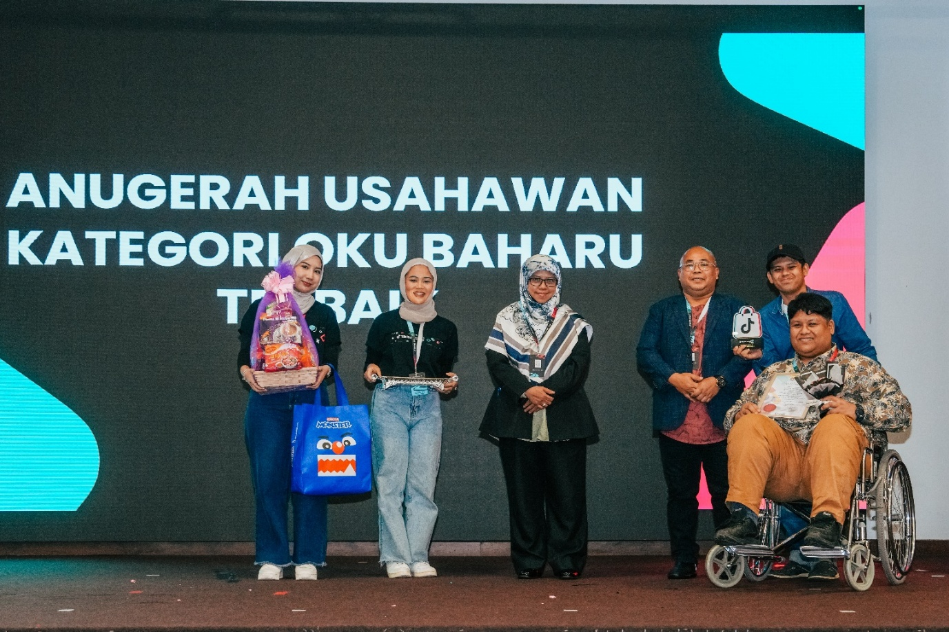
Figure 1: Nurezqi Enterprise, which began as a home-based business and operated at FAMA Farmers' Markets in Ipoh, Perak, has successfully expanded nationwide, including to Sabah and Sarawak, through online sales on the TikTok Shop platform. This achievement, catalysed by the Agromarketing Masterclass TikTok Shop Edition organised by FAMA, demonstrates the transformative impact of digital marketing adoption among entrepreneurs with disabilities. The company was awarded the Best New OKU Entrepreneur Award during the programme's live-streaming competition.

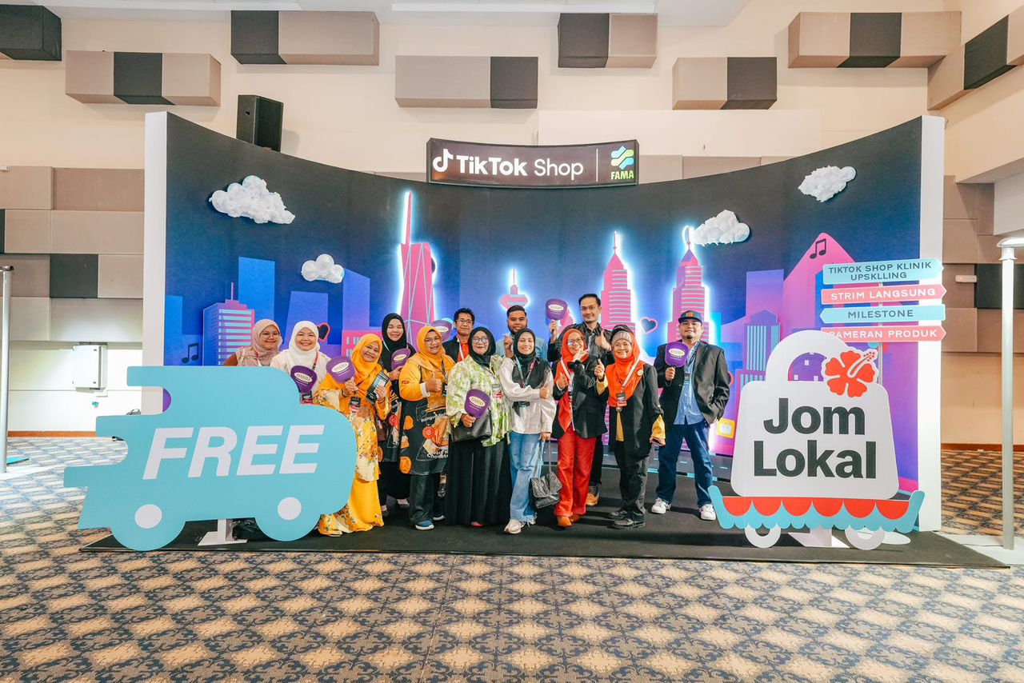
Figure 2: A group of FAMA entrepreneurs posing at the TikTok Shop x FAMA exhibition backdrop during the Agromarketing Masterclass TikTok Shop Edition event. The Jom Lokal campaign highlighted the importance of promoting locally produced agro-based products through digital commerce and live-streaming marketing on the TikTok Shop platform.
4.3 Sales Performance by Channel
Livestream selling was the highest-performing channel, generating RM2,105,670.00, or 33.9 per cent of total sales. Profile-window sales contributed RM1,875,034.00, short-video sales generated RM1,621,255.00, and other shop-tab activity contributed RM603,998.06. The important finding is not that one channel won; it is that the programme worked through multi-channel execution.
This has immediate training implications. Sellers need to be coached to run live sessions, create searchable and persuasive short videos, maintain a credible shop profile and keep product listings ready for conversion. Weakness in any one layer reduces the commercial effect of the others.
Table 3: Sales Value by Sales Channel in Agromarketing Masterclass TikTok Shop Edition (AMTTSE)
Sales Channel | Description | Sales Value (RM) | Share of Total (%)
Livestream | Sales generated through live-stream sessions conducted by FAMA entrepreneurs on TikTok Shop | 2,105,670.00 | 33.9
Short Video | Sales from short-video content that drives product visibility and conversions | 1,621,255.00 | 26.1
Window (Profile Sales) | Purchases made directly through the entrepreneur's TikTok Shop profile window | 1,875,034.00 | 30.1
Others (Shop Tab) | Sales recorded through the general Shop Tab browsing feature on TikTok Shop | 603,998.06 | 9.9
Total |  | 6,205,957.06 | 100.0
Source: FAMA TikTok Shop Performance Report (2024).

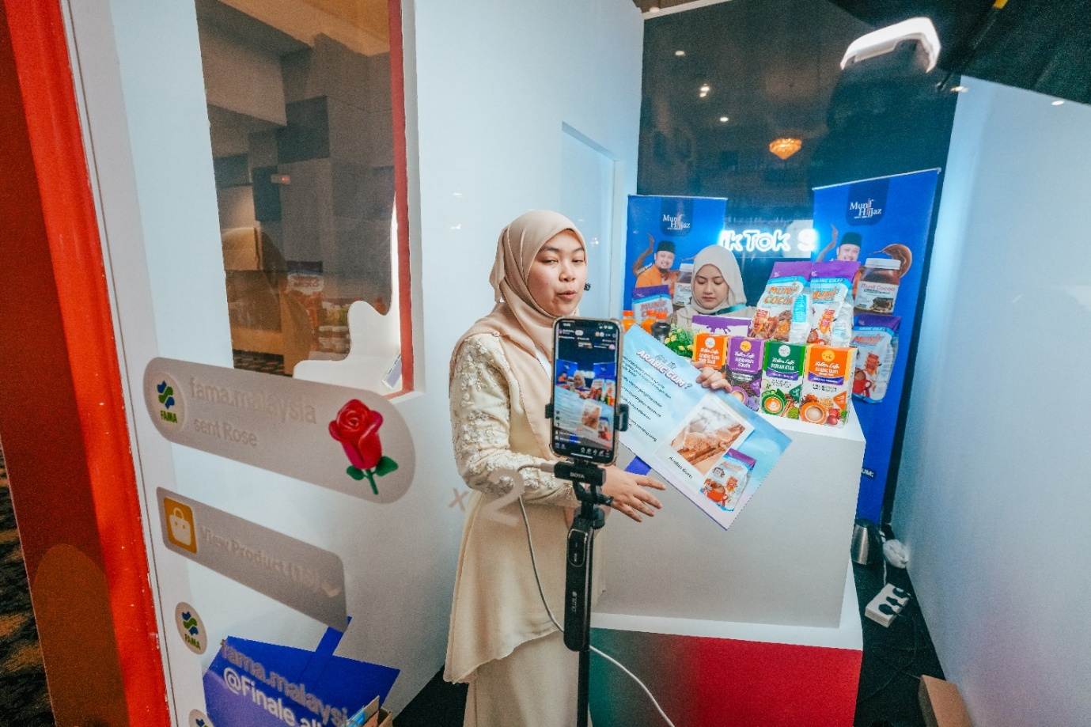
Figure 3: Munif Cocoa achieved the second-highest total sales value of RM736,162.87, following Azhar Food. The company's unexpected success was particularly remarkable as it marked their first experience with live-streaming sales. Participation in the Agromarketing Masterclass TikTok Shop Edition Live Streaming Competition encouraged the company to explore new online markets, significantly enhancing their digital business performance and market reach.
4.4 Monthly Performance Trends
Sales increased from RM497,762.95 in June to RM1,705,942.05 in December. Orders grew from 3,271 to 14,571, while products sold increased from 21,280 to 45,192. This is the clearest evidence that the programme gained operating momentum over time. Sellers were not only trained; the dataset suggests that they learned, repeated and improved.
The November and December acceleration may reflect seasonal demand, stronger content routines and accumulated platform learning. A practical programme reading is that follow-up support should be strongest after onboarding, because the largest gains may appear only after sellers have had enough time to experiment and adjust.

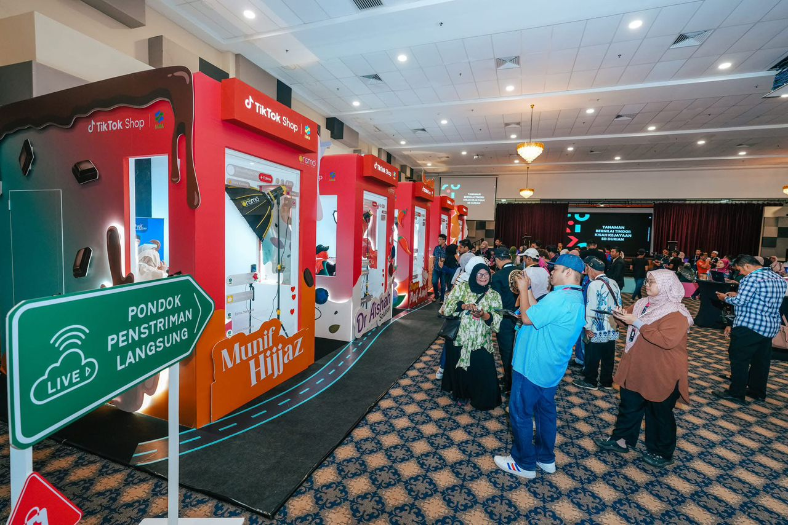
Figure 4: Visitors observing live-streaming sessions conducted by participating entrepreneurs in dedicated booths during the Agromarketing Masterclass TikTok Shop Edition Grand Final. The live-streaming pods, branded with participating companies such as Munif Hijjaz, served as experiential learning spaces where FAMA entrepreneurs demonstrated real-time digital marketing and e-commerce engagement strategies.
Table 4: Monthly Programme Performance, June to December 2024
Month | Total Sales (RM) | Livestream (RM) | Short Video (RM) | Products Sold | Orders
June | 497,762.95 | 194,759.55 | 180,940.23 | 21,280 | 3,271
July | 507,967.92 | 174,190.65 | 193,101.29 | 22,298 | 3,381
August | 728,225.46 | 259,453.12 | 300,783.08 | 34,583 | 4,645
September | 692,259.02 | 263,009.12 | 263,940.70 | 25,617 | 7,159
October | 814,482.14 | 323,530.03 | 317,551.16 | 32,334 | 6,164
November | 1,259,317.52 | 402,162.25 | 638,313.61 | 37,804 | 10,194
December | 1,705,942.05 | 582,847.27 | 871,599.37 | 45,192 | 14,571
Source: Projek Perintis Report (December 2024), Summary sheet.

4.5 Seller-Level GMV Distribution
Seller-level GMV shows that the programme’s benefits were concentrated. In December, 55 sellers recorded positive GMV while 25 sellers recorded zero GMV. The top ten sellers accounted for a large share of total performance. This should not be treated as programme failure; it is a normal platform-commerce pattern where visibility, consistency and conversion skill create uneven results.
The policy response should be segmentation. High performers need scaling support, campaign planning and inventory readiness. Moderate performers need conversion coaching. Inactive sellers need diagnosis: product-market fit, content fear, fulfilment issues, account setup problems or lack of discipline. Generic follow-up would waste the evidence already available.
Table 5: Top Ten Sellers by Gross Merchandise Value (GMV) in December 2024
Rank | Shop Name | Batch | SOF | OKU | GMV (RM)
1 | Chef Ustazah HQ | Batch 2 | N | No | 689,517.94
2 | kerepek azharfood | Batch 1 | N | No | 533,945.85
3 | Munif Cocoa @ Koko Spread Sedap | Batch 1 | N | No | 173,804.07
4 | DASTO HQ | Batch 2 | N | No | 107,254.26
5 | Dapur Pak Amir | Batch 1 | N | Yes | 39,562.30
6 | Baja Taiping | Batch 2 | N | No | 37,368.97
7 | Ayamhalalbismi | Batch 1 | Y | No | 20,120.58
8 | RIZQ MART | Batch 1 | Y | Yes | 15,701.73
9 | Corndog Anak Ramai HQ | Batch 2 | Y | No | 10,396.60
10 | agromasmalaysia | Batch 1 | N | No | 9,817.92
Source: Projek Perintis Report (December 2024), Seller GMV sheet. SOF = Sales from Farm. OKU = Orang Kurang Upaya (Persons with Disabilities).
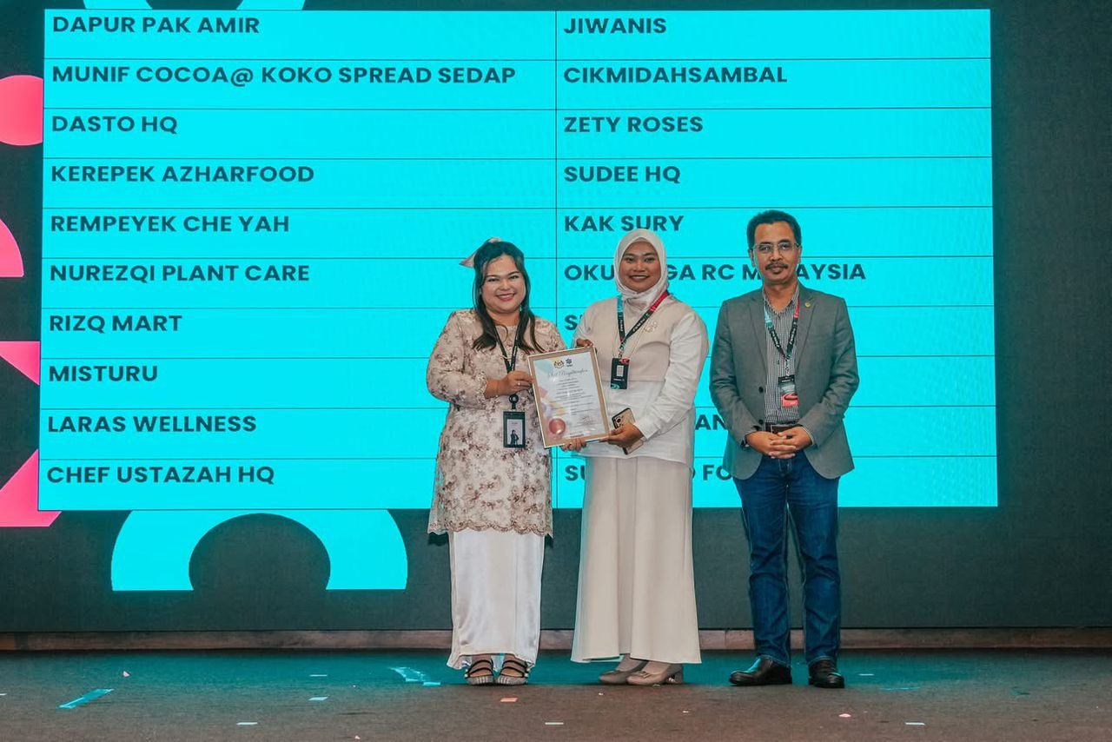
Figure 5: A representative from Misturu, one of the Top 20 finalists from Johor, receiving a certificate of recognition during the Agromarketing Masterclass TikTok Shop Edition Grand Final. The company's participation reflects the growing engagement of southern region entrepreneurs in adopting digital marketing strategies through the TikTok Shop platform, contributing to nationwide agri-entrepreneurial transformation.

4.6 Pearson Correlation Analysis
The correlation results support a commercial reading of the programme. Short-video sales, livestream sales, orders, shop-tab sales, profile-window sales and products sold were strongly associated with total monthly sales. These are monetised or movement-based indicators, meaning they sit close to actual purchasing behaviour.
The weaker result is just as important: content volume was not consistently significant. This is a useful correction to common digital-training advice. Asking entrepreneurs to post more is not enough. The operational priority is conversion quality: clearer product explanation, stronger offers, better timing, trust signals, fulfilment confidence and sharper calls to action.
Table 6: Pearson Correlation Analysis Using Monthly Aggregate Programme Data (n = 7)
Indicator correlated with total monthly sales | Pearson r | p-value | Significance
Livestream sales (RM) | 0.989 | <.0001 | **
Short-video sales (RM) | 0.997 | <.0001 | **
Profile/window sales (RM) | 0.971 | 0.0003 | **
Other/shop-tab sales (RM) | 0.972 | 0.0002 | **
Live-stream content volume | 0.720 | 0.0683 | ns
Short-video content volume | 0.414 | 0.3556 | ns
Total content volume | 0.538 | 0.2133 | ns
Products sold | 0.930 | 0.0024 | **
Products for sale | -0.011 | 0.9807 | ns
Orders | 0.977 | 0.0002 | **
Note: ** p < .01; ns = not significant. Source: Author's calculation based on Projek Perintis Report (December 2024).

5. DISCUSSION
The Agromarketing Masterclass TikTok Shop Edition generated measurable commercial outcomes because it combined training with market access and performance monitoring. This distinguishes it from digital-awareness programmes that celebrate participation but do not show revenue. The RM6.2 million cumulative sales outcome gives FAMA a credible basis to scale, provided the next phase is more targeted.
From the Resource-Based View, the productive resources were not generic digital literacy. They were specific selling capabilities: product storytelling, livestream confidence, storefront readiness, content discipline and response speed. Entrepreneurs who built these capabilities were better positioned to convert platform visibility into sales.
From the Dynamic Capabilities perspective, the monthly growth pattern indicates learning. Sellers had time to test content, adjust routines and respond to platform feedback. The programme’s value therefore sits partly in its monitoring period, not only in the initial training event.
The strongest caution is distribution. A strong total GMV can hide inactive sellers. Public agencies should avoid reporting only headline sales without activation rates, seller segmentation and seller-level improvement. The next stage of programme evaluation should show who improved, who stalled and why.

6. PRACTICAL IMPLICATIONS
FAMA should continue the programme but redesign the post-training layer. The next cohort should include conversion clinics, livestream scripts, product-bundle coaching, shop-profile audits, customer-response templates and fulfilment checks. Training should be less about platform orientation and more about sales execution.
Entrepreneurs should treat TikTok Shop as a disciplined selling system. Regular livestreams, targeted short videos, credible profile windows and fast customer response must work together. Listing more products is not enough, and producing more content is not enough. Commercial results depend on the ability to turn attention into orders.
7. POLICY IMPLICATIONS
The programme provides evidence that public-sector digitalisation can create direct economic returns when the design includes platform partnership and outcome tracking. Future programme budgets should include analytics infrastructure, not just training delivery. A dashboard should track seller activation, channel sales, order count, product movement, content activity and seller-level ROI.
Geographic concentration also requires policy attention. Less represented regions may need targeted recruitment, logistics support, internet-readiness assistance and regional mentors. Without these supports, social-commerce gains may cluster around already advantaged locations.

8. CONCLUSION
This study shows that the Agromarketing Masterclass TikTok Shop Edition produced measurable agribusiness outcomes: RM6,205,957.06 in cumulative sales, a reported ROI of 1:31, strong livestream and short-video contribution, and rising monthly orders and product movement. The evidence supports the view that social commerce can function as a credible agribusiness development instrument when training, platform access and monitoring are integrated.
The study also places limits around the claim. The available dataset supports aggregate programme-level association but does not prove seller-level causality. Future monitoring should collect live-session frequency, live duration, viewers, short-video views, click-through rates, conversion rates, average order values, repeat purchases and seller-level ROI.
The Big Pickle conclusion is practical: keep the programme, but make it sharper. Scale what works, segment sellers by performance, coach conversion rather than content volume, and build the analytics layer required to know which behaviours actually drive revenue. That is how a training initiative becomes durable market infrastructure for agropreneurs.

DATA AVAILABILITY
The data supporting the findings of this study are available from the corresponding author upon reasonable request.
FUNDING INFORMATION
This research received no external funding.
ETHICS APPROVAL
Not applicable.
CONFLICT OF INTEREST
The authors declare no conflict of interest.
AUTHOR CONTRIBUTIONS
Abd Razzif bin Abd Razak contributed to conceptualization, resources, data curation, writing original draft preparation, visualization, supervision, and project administration. Siti Faizah binti Zainal contributed to conceptualization, validation, data curation, visualization, and project administration. Siti Nurulaini binti Azmi contributed to methodology, validation, resources, writing original draft preparation, and supervision. Nur Hafizah binti Roslan contributed to methodology, software, formal analysis, investigation, and writing review and editing. Nur Syairah binti Ani contributed to software, formal analysis, investigation, and writing review and editing. All authors have read and approved the final version of the manuscript.
DISCLOSURE OF AI USE
AI tools were not used in the preparation of this manuscript.
ACKNOWLEDGEMENT
The authors express sincere appreciation to the Federal Agricultural Marketing Authority (FAMA), TikTok Shop Malaysia and all participating entrepreneurs involved in the Agromarketing Masterclass TikTok Shop Edition. Appreciation is also extended to the programme implementation and monitoring teams who contributed to the availability of performance data used in this study.

REFERENCES
Abdul Rahman, S. F., Tan, P.-L., & Md Isa, A. (2024). Technology adoption readiness among fresh agricultural traders in using e-commerce platform in Malaysia. Journal of Agribusiness Marketing, 13(2). https://doi.org/10.56527/jabm.13.2.5
Barney, J. (1991). Firm resources and sustained competitive advantage. Journal of Management, 17(1), 99-120. https://doi.org/10.1177/014920639101700108
Kaur, B., Kamarulzaman, N. H., & Hamzah, N. A. (2015). The impact of public-assisted contract farming programmes in Malaysia. Journal of Agribusiness Marketing, 7(1).
Creswell, J. W., & Creswell, J. D. (2018). Research design: Qualitative, quantitative, and mixed methods approaches (5th ed.). SAGE Publications.
FAMA. (2024). Projek Perintis Report (December 2024): Agromarketing Masterclass TikTok Shop Edition performance dataset. Federal Agricultural Marketing Authority.
Hajli, N. (2015). Social commerce constructs and consumer's intention to buy. International Journal of Information Management, 35(2), 183-191. https://doi.org/10.1016/j.ijinfomgt.2014.12.005
Halim, I. A., Gian Singh, J. K., & Osman, R. (2026). Bridging the digital gap: Factors influencing digital economy adoption in small enterprises. Journal of International Business, Economics and Entrepreneurship, 11(1), 32-42. https://doi.org/10.24191/jibe.v11i1.8520
Kraus, S., Palmer, C., Kailer, N., Kallinger, F. L., & Spitzer, J. (2022). Digital entrepreneurship: A research agenda on new business models for the twenty-first century. International Journal of Entrepreneurial Behavior & Research, 28(5), 1172-1193.
Nambisan, S. (2017). Digital entrepreneurship: Toward a digital technology perspective of entrepreneurship. Entrepreneurship Theory and Practice, 41(6), 1029-1055. https://doi.org/10.1111/etap.12254
Putit, L., Hamzah, M. I., Abdullah, M. F., Syed Annuar, S. N., & Yulianto, A. (2025). Drivers of social media marketing continuance among MSMEs in emerging economies. Journal of International Business, Economics and Entrepreneurship, 10(2), 86-97. https://doi.org/10.24191/jibe.v10i2.8743
Rauch, A., & Frese, M. (2007). Let's put the person back into entrepreneurship research: A meta-analysis on the relationship between business owners' personality traits, business creation and success. European Journal of Work and Organizational Psychology, 16(4), 353-385. https://doi.org/10.1080/13594320701595438
Safari, S., & Nik Mohd Masdek, N. R. (2015). Consumers' perception and acceptance of fresh agriculture product purchased through e-business. Journal of Agribusiness Marketing, 7(1).
Shamsudin, M. F., Musa, W. A., Jalaludin, M. N. H., & Jamaludin, A. (2025). Assessing the impact of FAMA's direct sales programmes on small agricultural producers in Malaysia: A conceptual analysis. Journal of Agribusiness Marketing, 14(1). https://doi.org/10.56527/jabm.14.1.2
Teece, D. J. (2018). Business models and dynamic capabilities. Long Range Planning, 51(1), 40-49. https://doi.org/10.1016/j.lrp.2017.06.007
Yin, R. K. (2018). Case study research and applications: Design and methods (6th ed.). SAGE Publications.

